**Requirements Specification Document**

**DryDocket**

**New Spaghetti Factory**

**October 30th, 2018**

[**Revision History**](https://docs.google.com/document/d/e/2PACX-1vTck6IuL3pFvBh2EBoL4GEdZlohOdd8N2iib6v9hCKzOpApW2FDvSKVgHaV-f5dFBPVbw9qM9TUqHY6/pub?embedded=true#h.ba7iu6753q4a) **[3](https://docs.google.com/document/d/e/2PACX-1vTck6IuL3pFvBh2EBoL4GEdZlohOdd8N2iib6v9hCKzOpApW2FDvSKVgHaV-f5dFBPVbw9qM9TUqHY6/pub?embedded=true#h.ba7iu6753q4a)**

[**1 Introduction**](https://docs.google.com/document/d/e/2PACX-1vTck6IuL3pFvBh2EBoL4GEdZlohOdd8N2iib6v9hCKzOpApW2FDvSKVgHaV-f5dFBPVbw9qM9TUqHY6/pub?embedded=true#h.88ehde71t3m4) **[4](https://docs.google.com/document/d/e/2PACX-1vTck6IuL3pFvBh2EBoL4GEdZlohOdd8N2iib6v9hCKzOpApW2FDvSKVgHaV-f5dFBPVbw9qM9TUqHY6/pub?embedded=true#h.88ehde71t3m4)**

[1.1 Purpose](https://docs.google.com/document/d/e/2PACX-1vTck6IuL3pFvBh2EBoL4GEdZlohOdd8N2iib6v9hCKzOpApW2FDvSKVgHaV-f5dFBPVbw9qM9TUqHY6/pub?embedded=true#h.31hvb813ezg2) [4](https://docs.google.com/document/d/e/2PACX-1vTck6IuL3pFvBh2EBoL4GEdZlohOdd8N2iib6v9hCKzOpApW2FDvSKVgHaV-f5dFBPVbw9qM9TUqHY6/pub?embedded=true#h.31hvb813ezg2)

[1.2 Project Scope](https://docs.google.com/document/d/e/2PACX-1vTck6IuL3pFvBh2EBoL4GEdZlohOdd8N2iib6v9hCKzOpApW2FDvSKVgHaV-f5dFBPVbw9qM9TUqHY6/pub?embedded=true#h.czkqrfohn7hm) [4](https://docs.google.com/document/d/e/2PACX-1vTck6IuL3pFvBh2EBoL4GEdZlohOdd8N2iib6v9hCKzOpApW2FDvSKVgHaV-f5dFBPVbw9qM9TUqHY6/pub?embedded=true#h.czkqrfohn7hm)

[1.3 Glossary of Terms](https://docs.google.com/document/d/e/2PACX-1vTck6IuL3pFvBh2EBoL4GEdZlohOdd8N2iib6v9hCKzOpApW2FDvSKVgHaV-f5dFBPVbw9qM9TUqHY6/pub?embedded=true#h.phqsacjutura) [4](https://docs.google.com/document/d/e/2PACX-1vTck6IuL3pFvBh2EBoL4GEdZlohOdd8N2iib6v9hCKzOpApW2FDvSKVgHaV-f5dFBPVbw9qM9TUqHY6/pub?embedded=true#h.phqsacjutura)

[1.4 References](https://docs.google.com/document/d/e/2PACX-1vTck6IuL3pFvBh2EBoL4GEdZlohOdd8N2iib6v9hCKzOpApW2FDvSKVgHaV-f5dFBPVbw9qM9TUqHY6/pub?embedded=true#h.6ctv9tdsh2xe) [6](https://docs.google.com/document/d/e/2PACX-1vTck6IuL3pFvBh2EBoL4GEdZlohOdd8N2iib6v9hCKzOpApW2FDvSKVgHaV-f5dFBPVbw9qM9TUqHY6/pub?embedded=true#h.6ctv9tdsh2xe)

[1.5 Overview](https://docs.google.com/document/d/e/2PACX-1vTck6IuL3pFvBh2EBoL4GEdZlohOdd8N2iib6v9hCKzOpApW2FDvSKVgHaV-f5dFBPVbw9qM9TUqHY6/pub?embedded=true#h.3aczb3u8ta5n) [6](https://docs.google.com/document/d/e/2PACX-1vTck6IuL3pFvBh2EBoL4GEdZlohOdd8N2iib6v9hCKzOpApW2FDvSKVgHaV-f5dFBPVbw9qM9TUqHY6/pub?embedded=true#h.3aczb3u8ta5n)

[**2 Overall Description**](https://docs.google.com/document/d/e/2PACX-1vTck6IuL3pFvBh2EBoL4GEdZlohOdd8N2iib6v9hCKzOpApW2FDvSKVgHaV-f5dFBPVbw9qM9TUqHY6/pub?embedded=true#h.sueev4euz2mk) **[6](https://docs.google.com/document/d/e/2PACX-1vTck6IuL3pFvBh2EBoL4GEdZlohOdd8N2iib6v9hCKzOpApW2FDvSKVgHaV-f5dFBPVbw9qM9TUqHY6/pub?embedded=true#h.sueev4euz2mk)**

[2.1 Product Perspective](https://docs.google.com/document/d/e/2PACX-1vTck6IuL3pFvBh2EBoL4GEdZlohOdd8N2iib6v9hCKzOpApW2FDvSKVgHaV-f5dFBPVbw9qM9TUqHY6/pub?embedded=true#h.nv123wif977q) [6](https://docs.google.com/document/d/e/2PACX-1vTck6IuL3pFvBh2EBoL4GEdZlohOdd8N2iib6v9hCKzOpApW2FDvSKVgHaV-f5dFBPVbw9qM9TUqHY6/pub?embedded=true#h.nv123wif977q)

[2.2 Product Features](https://docs.google.com/document/d/e/2PACX-1vTck6IuL3pFvBh2EBoL4GEdZlohOdd8N2iib6v9hCKzOpApW2FDvSKVgHaV-f5dFBPVbw9qM9TUqHY6/pub?embedded=true#h.61hu3m31zr7o) [6](https://docs.google.com/document/d/e/2PACX-1vTck6IuL3pFvBh2EBoL4GEdZlohOdd8N2iib6v9hCKzOpApW2FDvSKVgHaV-f5dFBPVbw9qM9TUqHY6/pub?embedded=true#h.61hu3m31zr7o)

[2.3 User Classes and Characteristics](https://docs.google.com/document/d/e/2PACX-1vTck6IuL3pFvBh2EBoL4GEdZlohOdd8N2iib6v9hCKzOpApW2FDvSKVgHaV-f5dFBPVbw9qM9TUqHY6/pub?embedded=true#h.jxysubipg6w4) [7](https://docs.google.com/document/d/e/2PACX-1vTck6IuL3pFvBh2EBoL4GEdZlohOdd8N2iib6v9hCKzOpApW2FDvSKVgHaV-f5dFBPVbw9qM9TUqHY6/pub?embedded=true#h.jxysubipg6w4)

[Accounting](https://docs.google.com/document/d/e/2PACX-1vTck6IuL3pFvBh2EBoL4GEdZlohOdd8N2iib6v9hCKzOpApW2FDvSKVgHaV-f5dFBPVbw9qM9TUqHY6/pub?embedded=true#h.z91kbr41i0kg) [7](https://docs.google.com/document/d/e/2PACX-1vTck6IuL3pFvBh2EBoL4GEdZlohOdd8N2iib6v9hCKzOpApW2FDvSKVgHaV-f5dFBPVbw9qM9TUqHY6/pub?embedded=true#h.z91kbr41i0kg)

[Management](https://docs.google.com/document/d/e/2PACX-1vTck6IuL3pFvBh2EBoL4GEdZlohOdd8N2iib6v9hCKzOpApW2FDvSKVgHaV-f5dFBPVbw9qM9TUqHY6/pub?embedded=true#h.pptmpxivaviw) [7](https://docs.google.com/document/d/e/2PACX-1vTck6IuL3pFvBh2EBoL4GEdZlohOdd8N2iib6v9hCKzOpApW2FDvSKVgHaV-f5dFBPVbw9qM9TUqHY6/pub?embedded=true#h.pptmpxivaviw)

[Sales](https://docs.google.com/document/d/e/2PACX-1vTck6IuL3pFvBh2EBoL4GEdZlohOdd8N2iib6v9hCKzOpApW2FDvSKVgHaV-f5dFBPVbw9qM9TUqHY6/pub?embedded=true#h.rsho01r8fpkt) [7](https://docs.google.com/document/d/e/2PACX-1vTck6IuL3pFvBh2EBoL4GEdZlohOdd8N2iib6v9hCKzOpApW2FDvSKVgHaV-f5dFBPVbw9qM9TUqHY6/pub?embedded=true#h.rsho01r8fpkt)

[Engineering](https://docs.google.com/document/d/e/2PACX-1vTck6IuL3pFvBh2EBoL4GEdZlohOdd8N2iib6v9hCKzOpApW2FDvSKVgHaV-f5dFBPVbw9qM9TUqHY6/pub?embedded=true#h.ufzruahg3j4q) [7](https://docs.google.com/document/d/e/2PACX-1vTck6IuL3pFvBh2EBoL4GEdZlohOdd8N2iib6v9hCKzOpApW2FDvSKVgHaV-f5dFBPVbw9qM9TUqHY6/pub?embedded=true#h.ufzruahg3j4q)

[Purchasing](https://docs.google.com/document/d/e/2PACX-1vTck6IuL3pFvBh2EBoL4GEdZlohOdd8N2iib6v9hCKzOpApW2FDvSKVgHaV-f5dFBPVbw9qM9TUqHY6/pub?embedded=true#h.gwjtsge8yumu) [7](https://docs.google.com/document/d/e/2PACX-1vTck6IuL3pFvBh2EBoL4GEdZlohOdd8N2iib6v9hCKzOpApW2FDvSKVgHaV-f5dFBPVbw9qM9TUqHY6/pub?embedded=true#h.gwjtsge8yumu)

[2.4 Operating Environment](https://docs.google.com/document/d/e/2PACX-1vTck6IuL3pFvBh2EBoL4GEdZlohOdd8N2iib6v9hCKzOpApW2FDvSKVgHaV-f5dFBPVbw9qM9TUqHY6/pub?embedded=true#h.4eaim1v0g8s9) [7](https://docs.google.com/document/d/e/2PACX-1vTck6IuL3pFvBh2EBoL4GEdZlohOdd8N2iib6v9hCKzOpApW2FDvSKVgHaV-f5dFBPVbw9qM9TUqHY6/pub?embedded=true#h.4eaim1v0g8s9)

[2.5 Design and Implementation Constraints](https://docs.google.com/document/d/e/2PACX-1vTck6IuL3pFvBh2EBoL4GEdZlohOdd8N2iib6v9hCKzOpApW2FDvSKVgHaV-f5dFBPVbw9qM9TUqHY6/pub?embedded=true#h.atvfu7j691fl) [8](https://docs.google.com/document/d/e/2PACX-1vTck6IuL3pFvBh2EBoL4GEdZlohOdd8N2iib6v9hCKzOpApW2FDvSKVgHaV-f5dFBPVbw9qM9TUqHY6/pub?embedded=true#h.atvfu7j691fl)

[2.6 Assumptions and dependencies](https://docs.google.com/document/d/e/2PACX-1vTck6IuL3pFvBh2EBoL4GEdZlohOdd8N2iib6v9hCKzOpApW2FDvSKVgHaV-f5dFBPVbw9qM9TUqHY6/pub?embedded=true#h.5i9xt793ck5z) [8](https://docs.google.com/document/d/e/2PACX-1vTck6IuL3pFvBh2EBoL4GEdZlohOdd8N2iib6v9hCKzOpApW2FDvSKVgHaV-f5dFBPVbw9qM9TUqHY6/pub?embedded=true#h.5i9xt793ck5z)

[**3 DryDocket Features**](https://docs.google.com/document/d/e/2PACX-1vTck6IuL3pFvBh2EBoL4GEdZlohOdd8N2iib6v9hCKzOpApW2FDvSKVgHaV-f5dFBPVbw9qM9TUqHY6/pub?embedded=true#h.gv4klm3berya) **[8](https://docs.google.com/document/d/e/2PACX-1vTck6IuL3pFvBh2EBoL4GEdZlohOdd8N2iib6v9hCKzOpApW2FDvSKVgHaV-f5dFBPVbw9qM9TUqHY6/pub?embedded=true#h.gv4klm3berya)**

[3.1 Data Access/Organization](https://docs.google.com/document/d/e/2PACX-1vTck6IuL3pFvBh2EBoL4GEdZlohOdd8N2iib6v9hCKzOpApW2FDvSKVgHaV-f5dFBPVbw9qM9TUqHY6/pub?embedded=true#h.8v1i67li3atu) [8](https://docs.google.com/document/d/e/2PACX-1vTck6IuL3pFvBh2EBoL4GEdZlohOdd8N2iib6v9hCKzOpApW2FDvSKVgHaV-f5dFBPVbw9qM9TUqHY6/pub?embedded=true#h.8v1i67li3atu)

[3.1.1 Description and Priority](https://docs.google.com/document/d/e/2PACX-1vTck6IuL3pFvBh2EBoL4GEdZlohOdd8N2iib6v9hCKzOpApW2FDvSKVgHaV-f5dFBPVbw9qM9TUqHY6/pub?embedded=true#h.l3yyr9lbdps5) [8](https://docs.google.com/document/d/e/2PACX-1vTck6IuL3pFvBh2EBoL4GEdZlohOdd8N2iib6v9hCKzOpApW2FDvSKVgHaV-f5dFBPVbw9qM9TUqHY6/pub?embedded=true#h.l3yyr9lbdps5)

[3.1.2 Functional Requirements](https://docs.google.com/document/d/e/2PACX-1vTck6IuL3pFvBh2EBoL4GEdZlohOdd8N2iib6v9hCKzOpApW2FDvSKVgHaV-f5dFBPVbw9qM9TUqHY6/pub?embedded=true#h.mjzjfai9iugx) [8](https://docs.google.com/document/d/e/2PACX-1vTck6IuL3pFvBh2EBoL4GEdZlohOdd8N2iib6v9hCKzOpApW2FDvSKVgHaV-f5dFBPVbw9qM9TUqHY6/pub?embedded=true#h.mjzjfai9iugx)

[3.1.2.1-SEARCH](https://docs.google.com/document/d/e/2PACX-1vTck6IuL3pFvBh2EBoL4GEdZlohOdd8N2iib6v9hCKzOpApW2FDvSKVgHaV-f5dFBPVbw9qM9TUqHY6/pub?embedded=true#h.7gaumfwmeeyu) [8](https://docs.google.com/document/d/e/2PACX-1vTck6IuL3pFvBh2EBoL4GEdZlohOdd8N2iib6v9hCKzOpApW2FDvSKVgHaV-f5dFBPVbw9qM9TUqHY6/pub?embedded=true#h.7gaumfwmeeyu)

[View Sales Quote](https://docs.google.com/document/d/e/2PACX-1vTck6IuL3pFvBh2EBoL4GEdZlohOdd8N2iib6v9hCKzOpApW2FDvSKVgHaV-f5dFBPVbw9qM9TUqHY6/pub?embedded=true#h.8aq4xlvunbu) [9](https://docs.google.com/document/d/e/2PACX-1vTck6IuL3pFvBh2EBoL4GEdZlohOdd8N2iib6v9hCKzOpApW2FDvSKVgHaV-f5dFBPVbw9qM9TUqHY6/pub?embedded=true#h.8aq4xlvunbu)

[View Work Order](https://docs.google.com/document/d/e/2PACX-1vTck6IuL3pFvBh2EBoL4GEdZlohOdd8N2iib6v9hCKzOpApW2FDvSKVgHaV-f5dFBPVbw9qM9TUqHY6/pub?embedded=true#h.wlwovq63wfjp) [11](https://docs.google.com/document/d/e/2PACX-1vTck6IuL3pFvBh2EBoL4GEdZlohOdd8N2iib6v9hCKzOpApW2FDvSKVgHaV-f5dFBPVbw9qM9TUqHY6/pub?embedded=true#h.wlwovq63wfjp)

[View After Action Report](https://docs.google.com/document/d/e/2PACX-1vTck6IuL3pFvBh2EBoL4GEdZlohOdd8N2iib6v9hCKzOpApW2FDvSKVgHaV-f5dFBPVbw9qM9TUqHY6/pub?embedded=true#h.ujkzpyhqutuu) [13](https://docs.google.com/document/d/e/2PACX-1vTck6IuL3pFvBh2EBoL4GEdZlohOdd8N2iib6v9hCKzOpApW2FDvSKVgHaV-f5dFBPVbw9qM9TUqHY6/pub?embedded=true#h.ujkzpyhqutuu)

[Build Step](https://docs.google.com/document/d/e/2PACX-1vTck6IuL3pFvBh2EBoL4GEdZlohOdd8N2iib6v9hCKzOpApW2FDvSKVgHaV-f5dFBPVbw9qM9TUqHY6/pub?embedded=true#h.5y68yd2dmxb1) [14](https://docs.google.com/document/d/e/2PACX-1vTck6IuL3pFvBh2EBoL4GEdZlohOdd8N2iib6v9hCKzOpApW2FDvSKVgHaV-f5dFBPVbw9qM9TUqHY6/pub?embedded=true#h.5y68yd2dmxb1)

[3.1.2.2-STORAGE](https://docs.google.com/document/d/e/2PACX-1vTck6IuL3pFvBh2EBoL4GEdZlohOdd8N2iib6v9hCKzOpApW2FDvSKVgHaV-f5dFBPVbw9qM9TUqHY6/pub?embedded=true#h.6nmhbg1yyq4) [15](https://docs.google.com/document/d/e/2PACX-1vTck6IuL3pFvBh2EBoL4GEdZlohOdd8N2iib6v9hCKzOpApW2FDvSKVgHaV-f5dFBPVbw9qM9TUqHY6/pub?embedded=true#h.6nmhbg1yyq4)

[3.1.2.3-BACKUP](https://docs.google.com/document/d/e/2PACX-1vTck6IuL3pFvBh2EBoL4GEdZlohOdd8N2iib6v9hCKzOpApW2FDvSKVgHaV-f5dFBPVbw9qM9TUqHY6/pub?embedded=true#h.ra0o0bhmesvj) [16](https://docs.google.com/document/d/e/2PACX-1vTck6IuL3pFvBh2EBoL4GEdZlohOdd8N2iib6v9hCKzOpApW2FDvSKVgHaV-f5dFBPVbw9qM9TUqHY6/pub?embedded=true#h.ra0o0bhmesvj)

[3.1.2.4-DOCUMENT-CREATION](https://docs.google.com/document/d/e/2PACX-1vTck6IuL3pFvBh2EBoL4GEdZlohOdd8N2iib6v9hCKzOpApW2FDvSKVgHaV-f5dFBPVbw9qM9TUqHY6/pub?embedded=true#h.gmrx2zad0svm) [16](https://docs.google.com/document/d/e/2PACX-1vTck6IuL3pFvBh2EBoL4GEdZlohOdd8N2iib6v9hCKzOpApW2FDvSKVgHaV-f5dFBPVbw9qM9TUqHY6/pub?embedded=true#h.gmrx2zad0svm)

[Create Quote](https://docs.google.com/document/d/e/2PACX-1vTck6IuL3pFvBh2EBoL4GEdZlohOdd8N2iib6v9hCKzOpApW2FDvSKVgHaV-f5dFBPVbw9qM9TUqHY6/pub?embedded=true#h.56t3mgidthn6) [16](https://docs.google.com/document/d/e/2PACX-1vTck6IuL3pFvBh2EBoL4GEdZlohOdd8N2iib6v9hCKzOpApW2FDvSKVgHaV-f5dFBPVbw9qM9TUqHY6/pub?embedded=true#h.56t3mgidthn6)

o[Create Work Order](https://docs.google.com/document/d/e/2PACX-1vTck6IuL3pFvBh2EBoL4GEdZlohOdd8N2iib6v9hCKzOpApW2FDvSKVgHaV-f5dFBPVbw9qM9TUqHY6/pub?embedded=true#h.lia09sld2sgo) [17](https://docs.google.com/document/d/e/2PACX-1vTck6IuL3pFvBh2EBoL4GEdZlohOdd8N2iib6v9hCKzOpApW2FDvSKVgHaV-f5dFBPVbw9qM9TUqHY6/pub?embedded=true#h.lia09sld2sgo)

[Create After Action Report](https://docs.google.com/document/d/e/2PACX-1vTck6IuL3pFvBh2EBoL4GEdZlohOdd8N2iib6v9hCKzOpApW2FDvSKVgHaV-f5dFBPVbw9qM9TUqHY6/pub?embedded=true#h.uwhq6yxow8es) [19](https://docs.google.com/document/d/e/2PACX-1vTck6IuL3pFvBh2EBoL4GEdZlohOdd8N2iib6v9hCKzOpApW2FDvSKVgHaV-f5dFBPVbw9qM9TUqHY6/pub?embedded=true#h.uwhq6yxow8es)

[Edit Form Fields](https://docs.google.com/document/d/e/2PACX-1vTck6IuL3pFvBh2EBoL4GEdZlohOdd8N2iib6v9hCKzOpApW2FDvSKVgHaV-f5dFBPVbw9qM9TUqHY6/pub?embedded=true#h.scivafdtg92z) [21](https://docs.google.com/document/d/e/2PACX-1vTck6IuL3pFvBh2EBoL4GEdZlohOdd8N2iib6v9hCKzOpApW2FDvSKVgHaV-f5dFBPVbw9qM9TUqHY6/pub?embedded=true#h.scivafdtg92z)

[3.2 Automated Document Generation](https://docs.google.com/document/d/e/2PACX-1vTck6IuL3pFvBh2EBoL4GEdZlohOdd8N2iib6v9hCKzOpApW2FDvSKVgHaV-f5dFBPVbw9qM9TUqHY6/pub?embedded=true#h.9zhmfew6xe42) [23](https://docs.google.com/document/d/e/2PACX-1vTck6IuL3pFvBh2EBoL4GEdZlohOdd8N2iib6v9hCKzOpApW2FDvSKVgHaV-f5dFBPVbw9qM9TUqHY6/pub?embedded=true#h.9zhmfew6xe42)

[3.2.1 Description and Priority](https://docs.google.com/document/d/e/2PACX-1vTck6IuL3pFvBh2EBoL4GEdZlohOdd8N2iib6v9hCKzOpApW2FDvSKVgHaV-f5dFBPVbw9qM9TUqHY6/pub?embedded=true#h.xoqmxacaldcg) [23](https://docs.google.com/document/d/e/2PACX-1vTck6IuL3pFvBh2EBoL4GEdZlohOdd8N2iib6v9hCKzOpApW2FDvSKVgHaV-f5dFBPVbw9qM9TUqHY6/pub?embedded=true#h.xoqmxacaldcg)

[3.2.2 Functional Requirements](https://docs.google.com/document/d/e/2PACX-1vTck6IuL3pFvBh2EBoL4GEdZlohOdd8N2iib6v9hCKzOpApW2FDvSKVgHaV-f5dFBPVbw9qM9TUqHY6/pub?embedded=true#h.dl7hxkez9om) [23](https://docs.google.com/document/d/e/2PACX-1vTck6IuL3pFvBh2EBoL4GEdZlohOdd8N2iib6v9hCKzOpApW2FDvSKVgHaV-f5dFBPVbw9qM9TUqHY6/pub?embedded=true#h.dl7hxkez9om)

[1- AUTOFILL](https://docs.google.com/document/d/e/2PACX-1vTck6IuL3pFvBh2EBoL4GEdZlohOdd8N2iib6v9hCKzOpApW2FDvSKVgHaV-f5dFBPVbw9qM9TUqHY6/pub?embedded=true#h.814p5ho1xxax) [23](https://docs.google.com/document/d/e/2PACX-1vTck6IuL3pFvBh2EBoL4GEdZlohOdd8N2iib6v9hCKzOpApW2FDvSKVgHaV-f5dFBPVbw9qM9TUqHY6/pub?embedded=true#h.814p5ho1xxax)

[3.3 Log-In/Out](https://docs.google.com/document/d/e/2PACX-1vTck6IuL3pFvBh2EBoL4GEdZlohOdd8N2iib6v9hCKzOpApW2FDvSKVgHaV-f5dFBPVbw9qM9TUqHY6/pub?embedded=true#h.fpidt48uvr5b) [24](https://docs.google.com/document/d/e/2PACX-1vTck6IuL3pFvBh2EBoL4GEdZlohOdd8N2iib6v9hCKzOpApW2FDvSKVgHaV-f5dFBPVbw9qM9TUqHY6/pub?embedded=true#h.fpidt48uvr5b)

[3.3.1 Description and Priority](https://docs.google.com/document/d/e/2PACX-1vTck6IuL3pFvBh2EBoL4GEdZlohOdd8N2iib6v9hCKzOpApW2FDvSKVgHaV-f5dFBPVbw9qM9TUqHY6/pub?embedded=true#h.494cduaf21le) [24](https://docs.google.com/document/d/e/2PACX-1vTck6IuL3pFvBh2EBoL4GEdZlohOdd8N2iib6v9hCKzOpApW2FDvSKVgHaV-f5dFBPVbw9qM9TUqHY6/pub?embedded=true#h.494cduaf21le)

[3.3.2 Functional Requirements](https://docs.google.com/document/d/e/2PACX-1vTck6IuL3pFvBh2EBoL4GEdZlohOdd8N2iib6v9hCKzOpApW2FDvSKVgHaV-f5dFBPVbw9qM9TUqHY6/pub?embedded=true#h.kcpd5162a60k) [24](https://docs.google.com/document/d/e/2PACX-1vTck6IuL3pFvBh2EBoL4GEdZlohOdd8N2iib6v9hCKzOpApW2FDvSKVgHaV-f5dFBPVbw9qM9TUqHY6/pub?embedded=true#h.kcpd5162a60k)

[1-LOGIN](https://docs.google.com/document/d/e/2PACX-1vTck6IuL3pFvBh2EBoL4GEdZlohOdd8N2iib6v9hCKzOpApW2FDvSKVgHaV-f5dFBPVbw9qM9TUqHY6/pub?embedded=true#h.m6gxdjvn8uoe) [24](https://docs.google.com/document/d/e/2PACX-1vTck6IuL3pFvBh2EBoL4GEdZlohOdd8N2iib6v9hCKzOpApW2FDvSKVgHaV-f5dFBPVbw9qM9TUqHY6/pub?embedded=true#h.m6gxdjvn8uoe)

[Login](https://docs.google.com/document/d/e/2PACX-1vTck6IuL3pFvBh2EBoL4GEdZlohOdd8N2iib6v9hCKzOpApW2FDvSKVgHaV-f5dFBPVbw9qM9TUqHY6/pub?embedded=true#h.5l385y4395z6) [25](https://docs.google.com/document/d/e/2PACX-1vTck6IuL3pFvBh2EBoL4GEdZlohOdd8N2iib6v9hCKzOpApW2FDvSKVgHaV-f5dFBPVbw9qM9TUqHY6/pub?embedded=true#h.5l385y4395z6)

[3.4 Profile Management](https://docs.google.com/document/d/e/2PACX-1vTck6IuL3pFvBh2EBoL4GEdZlohOdd8N2iib6v9hCKzOpApW2FDvSKVgHaV-f5dFBPVbw9qM9TUqHY6/pub?embedded=true#h.3drl8yobz6q) [27](https://docs.google.com/document/d/e/2PACX-1vTck6IuL3pFvBh2EBoL4GEdZlohOdd8N2iib6v9hCKzOpApW2FDvSKVgHaV-f5dFBPVbw9qM9TUqHY6/pub?embedded=true#h.3drl8yobz6q)

[3.4.1 Description and Priority](https://docs.google.com/document/d/e/2PACX-1vTck6IuL3pFvBh2EBoL4GEdZlohOdd8N2iib6v9hCKzOpApW2FDvSKVgHaV-f5dFBPVbw9qM9TUqHY6/pub?embedded=true#h.vv8481r53tad) [27](https://docs.google.com/document/d/e/2PACX-1vTck6IuL3pFvBh2EBoL4GEdZlohOdd8N2iib6v9hCKzOpApW2FDvSKVgHaV-f5dFBPVbw9qM9TUqHY6/pub?embedded=true#h.vv8481r53tad)

[3.4.2 Functional Requirements](https://docs.google.com/document/d/e/2PACX-1vTck6IuL3pFvBh2EBoL4GEdZlohOdd8N2iib6v9hCKzOpApW2FDvSKVgHaV-f5dFBPVbw9qM9TUqHY6/pub?embedded=true#h.ct0wdgoiqx3j) [27](https://docs.google.com/document/d/e/2PACX-1vTck6IuL3pFvBh2EBoL4GEdZlohOdd8N2iib6v9hCKzOpApW2FDvSKVgHaV-f5dFBPVbw9qM9TUqHY6/pub?embedded=true#h.ct0wdgoiqx3j)

[1- MANAGE PROFILES](https://docs.google.com/document/d/e/2PACX-1vTck6IuL3pFvBh2EBoL4GEdZlohOdd8N2iib6v9hCKzOpApW2FDvSKVgHaV-f5dFBPVbw9qM9TUqHY6/pub?embedded=true#h.k58e925d1nsy) [27](https://docs.google.com/document/d/e/2PACX-1vTck6IuL3pFvBh2EBoL4GEdZlohOdd8N2iib6v9hCKzOpApW2FDvSKVgHaV-f5dFBPVbw9qM9TUqHY6/pub?embedded=true#h.k58e925d1nsy)

[2- CUSTOM MEMBERSHIP PERMISSIONS (EMPLOYEES ONLY)](https://docs.google.com/document/d/e/2PACX-1vTck6IuL3pFvBh2EBoL4GEdZlohOdd8N2iib6v9hCKzOpApW2FDvSKVgHaV-f5dFBPVbw9qM9TUqHY6/pub?embedded=true#h.vdtkxycnibv5) [27](https://docs.google.com/document/d/e/2PACX-1vTck6IuL3pFvBh2EBoL4GEdZlohOdd8N2iib6v9hCKzOpApW2FDvSKVgHaV-f5dFBPVbw9qM9TUqHY6/pub?embedded=true#h.vdtkxycnibv5)

[Update Customer Profile](https://docs.google.com/document/d/e/2PACX-1vTck6IuL3pFvBh2EBoL4GEdZlohOdd8N2iib6v9hCKzOpApW2FDvSKVgHaV-f5dFBPVbw9qM9TUqHY6/pub?embedded=true#h.5c376z5davmu) [27](https://docs.google.com/document/d/e/2PACX-1vTck6IuL3pFvBh2EBoL4GEdZlohOdd8N2iib6v9hCKzOpApW2FDvSKVgHaV-f5dFBPVbw9qM9TUqHY6/pub?embedded=true#h.5c376z5davmu)

[Add Customer Profiles](https://docs.google.com/document/d/e/2PACX-1vTck6IuL3pFvBh2EBoL4GEdZlohOdd8N2iib6v9hCKzOpApW2FDvSKVgHaV-f5dFBPVbw9qM9TUqHY6/pub?embedded=true#h.iukxuo4bone0) [28](https://docs.google.com/document/d/e/2PACX-1vTck6IuL3pFvBh2EBoL4GEdZlohOdd8N2iib6v9hCKzOpApW2FDvSKVgHaV-f5dFBPVbw9qM9TUqHY6/pub?embedded=true#h.iukxuo4bone0)

[Add Employee Profiles](https://docs.google.com/document/d/e/2PACX-1vTck6IuL3pFvBh2EBoL4GEdZlohOdd8N2iib6v9hCKzOpApW2FDvSKVgHaV-f5dFBPVbw9qM9TUqHY6/pub?embedded=true#h.tjfwtra77ftb) [29](https://docs.google.com/document/d/e/2PACX-1vTck6IuL3pFvBh2EBoL4GEdZlohOdd8N2iib6v9hCKzOpApW2FDvSKVgHaV-f5dFBPVbw9qM9TUqHY6/pub?embedded=true#h.tjfwtra77ftb)

[Edit Employee Profiles](https://docs.google.com/document/d/e/2PACX-1vTck6IuL3pFvBh2EBoL4GEdZlohOdd8N2iib6v9hCKzOpApW2FDvSKVgHaV-f5dFBPVbw9qM9TUqHY6/pub?embedded=true#h.ddtryks2vu3q) [31](https://docs.google.com/document/d/e/2PACX-1vTck6IuL3pFvBh2EBoL4GEdZlohOdd8N2iib6v9hCKzOpApW2FDvSKVgHaV-f5dFBPVbw9qM9TUqHY6/pub?embedded=true#h.ddtryks2vu3q)

[3.5 Files Upload](https://docs.google.com/document/d/e/2PACX-1vTck6IuL3pFvBh2EBoL4GEdZlohOdd8N2iib6v9hCKzOpApW2FDvSKVgHaV-f5dFBPVbw9qM9TUqHY6/pub?embedded=true#h.rz3herv39qjn) [32](https://docs.google.com/document/d/e/2PACX-1vTck6IuL3pFvBh2EBoL4GEdZlohOdd8N2iib6v9hCKzOpApW2FDvSKVgHaV-f5dFBPVbw9qM9TUqHY6/pub?embedded=true#h.rz3herv39qjn)

[3.5.1 Description and Priority](https://docs.google.com/document/d/e/2PACX-1vTck6IuL3pFvBh2EBoL4GEdZlohOdd8N2iib6v9hCKzOpApW2FDvSKVgHaV-f5dFBPVbw9qM9TUqHY6/pub?embedded=true#h.8fs4psvhmkqk) [32](https://docs.google.com/document/d/e/2PACX-1vTck6IuL3pFvBh2EBoL4GEdZlohOdd8N2iib6v9hCKzOpApW2FDvSKVgHaV-f5dFBPVbw9qM9TUqHY6/pub?embedded=true#h.8fs4psvhmkqk)

[3.5.2 Functional Requirements](https://docs.google.com/document/d/e/2PACX-1vTck6IuL3pFvBh2EBoL4GEdZlohOdd8N2iib6v9hCKzOpApW2FDvSKVgHaV-f5dFBPVbw9qM9TUqHY6/pub?embedded=true#h.10vfsuf3uvuj) [32](https://docs.google.com/document/d/e/2PACX-1vTck6IuL3pFvBh2EBoL4GEdZlohOdd8N2iib6v9hCKzOpApW2FDvSKVgHaV-f5dFBPVbw9qM9TUqHY6/pub?embedded=true#h.10vfsuf3uvuj)

[Upload Engineering Documents](https://docs.google.com/document/d/e/2PACX-1vTck6IuL3pFvBh2EBoL4GEdZlohOdd8N2iib6v9hCKzOpApW2FDvSKVgHaV-f5dFBPVbw9qM9TUqHY6/pub?embedded=true#h.ih40diw3ue39) [33](https://docs.google.com/document/d/e/2PACX-1vTck6IuL3pFvBh2EBoL4GEdZlohOdd8N2iib6v9hCKzOpApW2FDvSKVgHaV-f5dFBPVbw9qM9TUqHY6/pub?embedded=true#h.ih40diw3ue39)

[3.6 Inventory](https://docs.google.com/document/d/e/2PACX-1vTck6IuL3pFvBh2EBoL4GEdZlohOdd8N2iib6v9hCKzOpApW2FDvSKVgHaV-f5dFBPVbw9qM9TUqHY6/pub?embedded=true#h.4e8k8kv63niv) [34](https://docs.google.com/document/d/e/2PACX-1vTck6IuL3pFvBh2EBoL4GEdZlohOdd8N2iib6v9hCKzOpApW2FDvSKVgHaV-f5dFBPVbw9qM9TUqHY6/pub?embedded=true#h.4e8k8kv63niv)

[Resupply Inventory](https://docs.google.com/document/d/e/2PACX-1vTck6IuL3pFvBh2EBoL4GEdZlohOdd8N2iib6v9hCKzOpApW2FDvSKVgHaV-f5dFBPVbw9qM9TUqHY6/pub?embedded=true#h.qxoe54h8pyrb) [34](https://docs.google.com/document/d/e/2PACX-1vTck6IuL3pFvBh2EBoL4GEdZlohOdd8N2iib6v9hCKzOpApW2FDvSKVgHaV-f5dFBPVbw9qM9TUqHY6/pub?embedded=true#h.qxoe54h8pyrb)

[Check Inventory](https://docs.google.com/document/d/e/2PACX-1vTck6IuL3pFvBh2EBoL4GEdZlohOdd8N2iib6v9hCKzOpApW2FDvSKVgHaV-f5dFBPVbw9qM9TUqHY6/pub?embedded=true#h.cg9s3ygmp1q9) [35](https://docs.google.com/document/d/e/2PACX-1vTck6IuL3pFvBh2EBoL4GEdZlohOdd8N2iib6v9hCKzOpApW2FDvSKVgHaV-f5dFBPVbw9qM9TUqHY6/pub?embedded=true#h.cg9s3ygmp1q9)

[Use Inventory Item](https://docs.google.com/document/d/e/2PACX-1vTck6IuL3pFvBh2EBoL4GEdZlohOdd8N2iib6v9hCKzOpApW2FDvSKVgHaV-f5dFBPVbw9qM9TUqHY6/pub?embedded=true#h.hjwgm7mdkhds) [36](https://docs.google.com/document/d/e/2PACX-1vTck6IuL3pFvBh2EBoL4GEdZlohOdd8N2iib6v9hCKzOpApW2FDvSKVgHaV-f5dFBPVbw9qM9TUqHY6/pub?embedded=true#h.hjwgm7mdkhds)

[**4 External Interface Requirements**](https://docs.google.com/document/d/e/2PACX-1vTck6IuL3pFvBh2EBoL4GEdZlohOdd8N2iib6v9hCKzOpApW2FDvSKVgHaV-f5dFBPVbw9qM9TUqHY6/pub?embedded=true#h.4slktkltol8v) **[37](https://docs.google.com/document/d/e/2PACX-1vTck6IuL3pFvBh2EBoL4GEdZlohOdd8N2iib6v9hCKzOpApW2FDvSKVgHaV-f5dFBPVbw9qM9TUqHY6/pub?embedded=true#h.4slktkltol8v)**

[4.1 User Interfaces](https://docs.google.com/document/d/e/2PACX-1vTck6IuL3pFvBh2EBoL4GEdZlohOdd8N2iib6v9hCKzOpApW2FDvSKVgHaV-f5dFBPVbw9qM9TUqHY6/pub?embedded=true#h.fqyafr9vm0lu) [38](https://docs.google.com/document/d/e/2PACX-1vTck6IuL3pFvBh2EBoL4GEdZlohOdd8N2iib6v9hCKzOpApW2FDvSKVgHaV-f5dFBPVbw9qM9TUqHY6/pub?embedded=true#h.fqyafr9vm0lu)

[4.1.1 Interface Accessibility](https://docs.google.com/document/d/e/2PACX-1vTck6IuL3pFvBh2EBoL4GEdZlohOdd8N2iib6v9hCKzOpApW2FDvSKVgHaV-f5dFBPVbw9qM9TUqHY6/pub?embedded=true#h.wcg2xmvv5qzy) [38](https://docs.google.com/document/d/e/2PACX-1vTck6IuL3pFvBh2EBoL4GEdZlohOdd8N2iib6v9hCKzOpApW2FDvSKVgHaV-f5dFBPVbw9qM9TUqHY6/pub?embedded=true#h.wcg2xmvv5qzy)

[4.1.2 Interface Dropdown Menus](https://docs.google.com/document/d/e/2PACX-1vTck6IuL3pFvBh2EBoL4GEdZlohOdd8N2iib6v9hCKzOpApW2FDvSKVgHaV-f5dFBPVbw9qM9TUqHY6/pub?embedded=true#h.ih1epkiiaxhp) [38](https://docs.google.com/document/d/e/2PACX-1vTck6IuL3pFvBh2EBoL4GEdZlohOdd8N2iib6v9hCKzOpApW2FDvSKVgHaV-f5dFBPVbw9qM9TUqHY6/pub?embedded=true#h.ih1epkiiaxhp)

[4.1.3 Previous Order Template](https://docs.google.com/document/d/e/2PACX-1vTck6IuL3pFvBh2EBoL4GEdZlohOdd8N2iib6v9hCKzOpApW2FDvSKVgHaV-f5dFBPVbw9qM9TUqHY6/pub?embedded=true#h.8mpsjt6vnej2) [38](https://docs.google.com/document/d/e/2PACX-1vTck6IuL3pFvBh2EBoL4GEdZlohOdd8N2iib6v9hCKzOpApW2FDvSKVgHaV-f5dFBPVbw9qM9TUqHY6/pub?embedded=true#h.8mpsjt6vnej2)

[4.2 Hardware Interfaces](https://docs.google.com/document/d/e/2PACX-1vTck6IuL3pFvBh2EBoL4GEdZlohOdd8N2iib6v9hCKzOpApW2FDvSKVgHaV-f5dFBPVbw9qM9TUqHY6/pub?embedded=true#h.su47rp6q0qc8) [38](https://docs.google.com/document/d/e/2PACX-1vTck6IuL3pFvBh2EBoL4GEdZlohOdd8N2iib6v9hCKzOpApW2FDvSKVgHaV-f5dFBPVbw9qM9TUqHY6/pub?embedded=true#h.su47rp6q0qc8)

[4.3 Software Interfaces](https://docs.google.com/document/d/e/2PACX-1vTck6IuL3pFvBh2EBoL4GEdZlohOdd8N2iib6v9hCKzOpApW2FDvSKVgHaV-f5dFBPVbw9qM9TUqHY6/pub?embedded=true#h.wdx7tdaapqat) [38](https://docs.google.com/document/d/e/2PACX-1vTck6IuL3pFvBh2EBoL4GEdZlohOdd8N2iib6v9hCKzOpApW2FDvSKVgHaV-f5dFBPVbw9qM9TUqHY6/pub?embedded=true#h.wdx7tdaapqat)

[4.3.1 Backup Data Export](https://docs.google.com/document/d/e/2PACX-1vTck6IuL3pFvBh2EBoL4GEdZlohOdd8N2iib6v9hCKzOpApW2FDvSKVgHaV-f5dFBPVbw9qM9TUqHY6/pub?embedded=true#h.xezohn1lafpf) [38](https://docs.google.com/document/d/e/2PACX-1vTck6IuL3pFvBh2EBoL4GEdZlohOdd8N2iib6v9hCKzOpApW2FDvSKVgHaV-f5dFBPVbw9qM9TUqHY6/pub?embedded=true#h.xezohn1lafpf)

[4.4 Communications Interfaces](https://docs.google.com/document/d/e/2PACX-1vTck6IuL3pFvBh2EBoL4GEdZlohOdd8N2iib6v9hCKzOpApW2FDvSKVgHaV-f5dFBPVbw9qM9TUqHY6/pub?embedded=true#h.65o0d7iw1ts3) [39](https://docs.google.com/document/d/e/2PACX-1vTck6IuL3pFvBh2EBoL4GEdZlohOdd8N2iib6v9hCKzOpApW2FDvSKVgHaV-f5dFBPVbw9qM9TUqHY6/pub?embedded=true#h.65o0d7iw1ts3)

[4.4.1 Email Communication](https://docs.google.com/document/d/e/2PACX-1vTck6IuL3pFvBh2EBoL4GEdZlohOdd8N2iib6v9hCKzOpApW2FDvSKVgHaV-f5dFBPVbw9qM9TUqHY6/pub?embedded=true#h.lw061x9lciop) [39](https://docs.google.com/document/d/e/2PACX-1vTck6IuL3pFvBh2EBoL4GEdZlohOdd8N2iib6v9hCKzOpApW2FDvSKVgHaV-f5dFBPVbw9qM9TUqHY6/pub?embedded=true#h.lw061x9lciop)

[**5 Other Non Functional Requirements**](https://docs.google.com/document/d/e/2PACX-1vTck6IuL3pFvBh2EBoL4GEdZlohOdd8N2iib6v9hCKzOpApW2FDvSKVgHaV-f5dFBPVbw9qM9TUqHY6/pub?embedded=true#h.75vh2xi4ojge) **[39](https://docs.google.com/document/d/e/2PACX-1vTck6IuL3pFvBh2EBoL4GEdZlohOdd8N2iib6v9hCKzOpApW2FDvSKVgHaV-f5dFBPVbw9qM9TUqHY6/pub?embedded=true#h.75vh2xi4ojge)**

[5.1 Performance Requirements](https://docs.google.com/document/d/e/2PACX-1vTck6IuL3pFvBh2EBoL4GEdZlohOdd8N2iib6v9hCKzOpApW2FDvSKVgHaV-f5dFBPVbw9qM9TUqHY6/pub?embedded=true#h.bcw2nuywhxc1) [39](https://docs.google.com/document/d/e/2PACX-1vTck6IuL3pFvBh2EBoL4GEdZlohOdd8N2iib6v9hCKzOpApW2FDvSKVgHaV-f5dFBPVbw9qM9TUqHY6/pub?embedded=true#h.bcw2nuywhxc1)

[5.1.1 Concurrent Connections](https://docs.google.com/document/d/e/2PACX-1vTck6IuL3pFvBh2EBoL4GEdZlohOdd8N2iib6v9hCKzOpApW2FDvSKVgHaV-f5dFBPVbw9qM9TUqHY6/pub?embedded=true#h.bt56e5zzs2b) [39](https://docs.google.com/document/d/e/2PACX-1vTck6IuL3pFvBh2EBoL4GEdZlohOdd8N2iib6v9hCKzOpApW2FDvSKVgHaV-f5dFBPVbw9qM9TUqHY6/pub?embedded=true#h.bt56e5zzs2b)

[5.1.2 Form Access Time](https://docs.google.com/document/d/e/2PACX-1vTck6IuL3pFvBh2EBoL4GEdZlohOdd8N2iib6v9hCKzOpApW2FDvSKVgHaV-f5dFBPVbw9qM9TUqHY6/pub?embedded=true#h.cwy4susaqp8c) [39](https://docs.google.com/document/d/e/2PACX-1vTck6IuL3pFvBh2EBoL4GEdZlohOdd8N2iib6v9hCKzOpApW2FDvSKVgHaV-f5dFBPVbw9qM9TUqHY6/pub?embedded=true#h.cwy4susaqp8c)

[5.1.3 Database Search Query](https://docs.google.com/document/d/e/2PACX-1vTck6IuL3pFvBh2EBoL4GEdZlohOdd8N2iib6v9hCKzOpApW2FDvSKVgHaV-f5dFBPVbw9qM9TUqHY6/pub?embedded=true#h.fv3436hjcuke) [40](https://docs.google.com/document/d/e/2PACX-1vTck6IuL3pFvBh2EBoL4GEdZlohOdd8N2iib6v9hCKzOpApW2FDvSKVgHaV-f5dFBPVbw9qM9TUqHY6/pub?embedded=true#h.fv3436hjcuke)

[5.1.4 Employee Profile Creation Usability](https://docs.google.com/document/d/e/2PACX-1vTck6IuL3pFvBh2EBoL4GEdZlohOdd8N2iib6v9hCKzOpApW2FDvSKVgHaV-f5dFBPVbw9qM9TUqHY6/pub?embedded=true#h.qas0vf98tqww) [40](https://docs.google.com/document/d/e/2PACX-1vTck6IuL3pFvBh2EBoL4GEdZlohOdd8N2iib6v9hCKzOpApW2FDvSKVgHaV-f5dFBPVbw9qM9TUqHY6/pub?embedded=true#h.qas0vf98tqww)

[5.1.5 Employee Permission Changes](https://docs.google.com/document/d/e/2PACX-1vTck6IuL3pFvBh2EBoL4GEdZlohOdd8N2iib6v9hCKzOpApW2FDvSKVgHaV-f5dFBPVbw9qM9TUqHY6/pub?embedded=true#h.ntavbvpfq340) [40](https://docs.google.com/document/d/e/2PACX-1vTck6IuL3pFvBh2EBoL4GEdZlohOdd8N2iib6v9hCKzOpApW2FDvSKVgHaV-f5dFBPVbw9qM9TUqHY6/pub?embedded=true#h.ntavbvpfq340)

[5.1.6 Form Autofill](https://docs.google.com/document/d/e/2PACX-1vTck6IuL3pFvBh2EBoL4GEdZlohOdd8N2iib6v9hCKzOpApW2FDvSKVgHaV-f5dFBPVbw9qM9TUqHY6/pub?embedded=true#h.l7jbxzxahvax) [41](https://docs.google.com/document/d/e/2PACX-1vTck6IuL3pFvBh2EBoL4GEdZlohOdd8N2iib6v9hCKzOpApW2FDvSKVgHaV-f5dFBPVbw9qM9TUqHY6/pub?embedded=true#h.l7jbxzxahvax)

[5.2 Safety Requirements](https://docs.google.com/document/d/e/2PACX-1vTck6IuL3pFvBh2EBoL4GEdZlohOdd8N2iib6v9hCKzOpApW2FDvSKVgHaV-f5dFBPVbw9qM9TUqHY6/pub?embedded=true#h.fb0qud6lxu5b) [41](https://docs.google.com/document/d/e/2PACX-1vTck6IuL3pFvBh2EBoL4GEdZlohOdd8N2iib6v9hCKzOpApW2FDvSKVgHaV-f5dFBPVbw9qM9TUqHY6/pub?embedded=true#h.fb0qud6lxu5b)

[5.2.1 Previous Interface Backup System](https://docs.google.com/document/d/e/2PACX-1vTck6IuL3pFvBh2EBoL4GEdZlohOdd8N2iib6v9hCKzOpApW2FDvSKVgHaV-f5dFBPVbw9qM9TUqHY6/pub?embedded=true#h.q532tv3ur36b) [41](https://docs.google.com/document/d/e/2PACX-1vTck6IuL3pFvBh2EBoL4GEdZlohOdd8N2iib6v9hCKzOpApW2FDvSKVgHaV-f5dFBPVbw9qM9TUqHY6/pub?embedded=true#h.q532tv3ur36b)

[5.2.2 Off-Site Backup](https://docs.google.com/document/d/e/2PACX-1vTck6IuL3pFvBh2EBoL4GEdZlohOdd8N2iib6v9hCKzOpApW2FDvSKVgHaV-f5dFBPVbw9qM9TUqHY6/pub?embedded=true#h.8duq27cxh5vz) [41](https://docs.google.com/document/d/e/2PACX-1vTck6IuL3pFvBh2EBoL4GEdZlohOdd8N2iib6v9hCKzOpApW2FDvSKVgHaV-f5dFBPVbw9qM9TUqHY6/pub?embedded=true#h.8duq27cxh5vz)

[5.2.4 Unique Backup File](https://docs.google.com/document/d/e/2PACX-1vTck6IuL3pFvBh2EBoL4GEdZlohOdd8N2iib6v9hCKzOpApW2FDvSKVgHaV-f5dFBPVbw9qM9TUqHY6/pub?embedded=true#h.tp2t1fqficbw) [41](https://docs.google.com/document/d/e/2PACX-1vTck6IuL3pFvBh2EBoL4GEdZlohOdd8N2iib6v9hCKzOpApW2FDvSKVgHaV-f5dFBPVbw9qM9TUqHY6/pub?embedded=true#h.tp2t1fqficbw)

[5.3 Security Requirements](https://docs.google.com/document/d/e/2PACX-1vTck6IuL3pFvBh2EBoL4GEdZlohOdd8N2iib6v9hCKzOpApW2FDvSKVgHaV-f5dFBPVbw9qM9TUqHY6/pub?embedded=true#h.m5dc8x5qp41l) [42](https://docs.google.com/document/d/e/2PACX-1vTck6IuL3pFvBh2EBoL4GEdZlohOdd8N2iib6v9hCKzOpApW2FDvSKVgHaV-f5dFBPVbw9qM9TUqHY6/pub?embedded=true#h.m5dc8x5qp41l)

[5.3.1 Part Diagram Access Permissions](https://docs.google.com/document/d/e/2PACX-1vTck6IuL3pFvBh2EBoL4GEdZlohOdd8N2iib6v9hCKzOpApW2FDvSKVgHaV-f5dFBPVbw9qM9TUqHY6/pub?embedded=true#h.wu4gp8e1u18q) [42](https://docs.google.com/document/d/e/2PACX-1vTck6IuL3pFvBh2EBoL4GEdZlohOdd8N2iib6v9hCKzOpApW2FDvSKVgHaV-f5dFBPVbw9qM9TUqHY6/pub?embedded=true#h.wu4gp8e1u18q)

[5.3.2 Gaining Access to DryDocket](https://docs.google.com/document/d/e/2PACX-1vTck6IuL3pFvBh2EBoL4GEdZlohOdd8N2iib6v9hCKzOpApW2FDvSKVgHaV-f5dFBPVbw9qM9TUqHY6/pub?embedded=true#h.91r74a2bk87k) [42](https://docs.google.com/document/d/e/2PACX-1vTck6IuL3pFvBh2EBoL4GEdZlohOdd8N2iib6v9hCKzOpApW2FDvSKVgHaV-f5dFBPVbw9qM9TUqHY6/pub?embedded=true#h.91r74a2bk87k)

[5.3.4 Captured Data Confidentiality](https://docs.google.com/document/d/e/2PACX-1vTck6IuL3pFvBh2EBoL4GEdZlohOdd8N2iib6v9hCKzOpApW2FDvSKVgHaV-f5dFBPVbw9qM9TUqHY6/pub?embedded=true#h.v7036eo4f59m) [42](https://docs.google.com/document/d/e/2PACX-1vTck6IuL3pFvBh2EBoL4GEdZlohOdd8N2iib6v9hCKzOpApW2FDvSKVgHaV-f5dFBPVbw9qM9TUqHY6/pub?embedded=true#h.v7036eo4f59m)

[5.3.5 File Deletion](https://docs.google.com/document/d/e/2PACX-1vTck6IuL3pFvBh2EBoL4GEdZlohOdd8N2iib6v9hCKzOpApW2FDvSKVgHaV-f5dFBPVbw9qM9TUqHY6/pub?embedded=true#h.l1747w4wiwnj) [42](https://docs.google.com/document/d/e/2PACX-1vTck6IuL3pFvBh2EBoL4GEdZlohOdd8N2iib6v9hCKzOpApW2FDvSKVgHaV-f5dFBPVbw9qM9TUqHY6/pub?embedded=true#h.l1747w4wiwnj)

[5.3.6 Role Management](https://docs.google.com/document/d/e/2PACX-1vTck6IuL3pFvBh2EBoL4GEdZlohOdd8N2iib6v9hCKzOpApW2FDvSKVgHaV-f5dFBPVbw9qM9TUqHY6/pub?embedded=true#h.eytj3i9hftdp) [43](https://docs.google.com/document/d/e/2PACX-1vTck6IuL3pFvBh2EBoL4GEdZlohOdd8N2iib6v9hCKzOpApW2FDvSKVgHaV-f5dFBPVbw9qM9TUqHY6/pub?embedded=true#h.eytj3i9hftdp)

[5.3.7 True Cost Analysis](https://docs.google.com/document/d/e/2PACX-1vTck6IuL3pFvBh2EBoL4GEdZlohOdd8N2iib6v9hCKzOpApW2FDvSKVgHaV-f5dFBPVbw9qM9TUqHY6/pub?embedded=true#h.d3l3uquzj7nm) [43](https://docs.google.com/document/d/e/2PACX-1vTck6IuL3pFvBh2EBoL4GEdZlohOdd8N2iib6v9hCKzOpApW2FDvSKVgHaV-f5dFBPVbw9qM9TUqHY6/pub?embedded=true#h.d3l3uquzj7nm)

[5.4 Software Quality Attributes](https://docs.google.com/document/d/e/2PACX-1vTck6IuL3pFvBh2EBoL4GEdZlohOdd8N2iib6v9hCKzOpApW2FDvSKVgHaV-f5dFBPVbw9qM9TUqHY6/pub?embedded=true#h.eeztifv8krex) [43](https://docs.google.com/document/d/e/2PACX-1vTck6IuL3pFvBh2EBoL4GEdZlohOdd8N2iib6v9hCKzOpApW2FDvSKVgHaV-f5dFBPVbw9qM9TUqHY6/pub?embedded=true#h.eeztifv8krex)

[5.4.1 Application Portability](https://docs.google.com/document/d/e/2PACX-1vTck6IuL3pFvBh2EBoL4GEdZlohOdd8N2iib6v9hCKzOpApW2FDvSKVgHaV-f5dFBPVbw9qM9TUqHY6/pub?embedded=true#h.h3khmz3c0zli) [43](https://docs.google.com/document/d/e/2PACX-1vTck6IuL3pFvBh2EBoL4GEdZlohOdd8N2iib6v9hCKzOpApW2FDvSKVgHaV-f5dFBPVbw9qM9TUqHY6/pub?embedded=true#h.h3khmz3c0zli)

[5.4.2 Availability During Updates](https://docs.google.com/document/d/e/2PACX-1vTck6IuL3pFvBh2EBoL4GEdZlohOdd8N2iib6v9hCKzOpApW2FDvSKVgHaV-f5dFBPVbw9qM9TUqHY6/pub?embedded=true#h.jwkij6p08sp) [44](https://docs.google.com/document/d/e/2PACX-1vTck6IuL3pFvBh2EBoL4GEdZlohOdd8N2iib6v9hCKzOpApW2FDvSKVgHaV-f5dFBPVbw9qM9TUqHY6/pub?embedded=true#h.jwkij6p08sp)

[5.4.3 DryDocket Failover](https://docs.google.com/document/d/e/2PACX-1vTck6IuL3pFvBh2EBoL4GEdZlohOdd8N2iib6v9hCKzOpApW2FDvSKVgHaV-f5dFBPVbw9qM9TUqHY6/pub?embedded=true#h.m6302135bovm) [44](https://docs.google.com/document/d/e/2PACX-1vTck6IuL3pFvBh2EBoL4GEdZlohOdd8N2iib6v9hCKzOpApW2FDvSKVgHaV-f5dFBPVbw9qM9TUqHY6/pub?embedded=true#h.m6302135bovm)

[**6 Additional Requirements**](https://docs.google.com/document/d/e/2PACX-1vTck6IuL3pFvBh2EBoL4GEdZlohOdd8N2iib6v9hCKzOpApW2FDvSKVgHaV-f5dFBPVbw9qM9TUqHY6/pub?embedded=true#h.9d4tbux4k5ur) **[44](https://docs.google.com/document/d/e/2PACX-1vTck6IuL3pFvBh2EBoL4GEdZlohOdd8N2iib6v9hCKzOpApW2FDvSKVgHaV-f5dFBPVbw9qM9TUqHY6/pub?embedded=true#h.9d4tbux4k5ur)**

[**7 Analysis Models**](https://docs.google.com/document/d/e/2PACX-1vTck6IuL3pFvBh2EBoL4GEdZlohOdd8N2iib6v9hCKzOpApW2FDvSKVgHaV-f5dFBPVbw9qM9TUqHY6/pub?embedded=true#h.20qvxqzczgv6) **[44](https://docs.google.com/document/d/e/2PACX-1vTck6IuL3pFvBh2EBoL4GEdZlohOdd8N2iib6v9hCKzOpApW2FDvSKVgHaV-f5dFBPVbw9qM9TUqHY6/pub?embedded=true#h.20qvxqzczgv6)**

[7.1 Use Case Model](https://docs.google.com/document/d/e/2PACX-1vTck6IuL3pFvBh2EBoL4GEdZlohOdd8N2iib6v9hCKzOpApW2FDvSKVgHaV-f5dFBPVbw9qM9TUqHY6/pub?embedded=true#h.14p7p6wg4gwo) [45](https://docs.google.com/document/d/e/2PACX-1vTck6IuL3pFvBh2EBoL4GEdZlohOdd8N2iib6v9hCKzOpApW2FDvSKVgHaV-f5dFBPVbw9qM9TUqHY6/pub?embedded=true#h.14p7p6wg4gwo)

[7.2 Entity Relationship Diagram](https://docs.google.com/document/d/e/2PACX-1vTck6IuL3pFvBh2EBoL4GEdZlohOdd8N2iib6v9hCKzOpApW2FDvSKVgHaV-f5dFBPVbw9qM9TUqHY6/pub?embedded=true#h.u6lt5lhjwiod) [46](https://docs.google.com/document/d/e/2PACX-1vTck6IuL3pFvBh2EBoL4GEdZlohOdd8N2iib6v9hCKzOpApW2FDvSKVgHaV-f5dFBPVbw9qM9TUqHY6/pub?embedded=true#h.u6lt5lhjwiod)

[7.3 Data Flow Diagrams](https://docs.google.com/document/d/e/2PACX-1vTck6IuL3pFvBh2EBoL4GEdZlohOdd8N2iib6v9hCKzOpApW2FDvSKVgHaV-f5dFBPVbw9qM9TUqHY6/pub?embedded=true#h.m009t7sz4lo5) [46](https://docs.google.com/document/d/e/2PACX-1vTck6IuL3pFvBh2EBoL4GEdZlohOdd8N2iib6v9hCKzOpApW2FDvSKVgHaV-f5dFBPVbw9qM9TUqHY6/pub?embedded=true#h.m009t7sz4lo5)

[7.3.1 [DFD 0]](https://docs.google.com/document/d/e/2PACX-1vTck6IuL3pFvBh2EBoL4GEdZlohOdd8N2iib6v9hCKzOpApW2FDvSKVgHaV-f5dFBPVbw9qM9TUqHY6/pub?embedded=true#h.qgd47np7wof6) [46](https://docs.google.com/document/d/e/2PACX-1vTck6IuL3pFvBh2EBoL4GEdZlohOdd8N2iib6v9hCKzOpApW2FDvSKVgHaV-f5dFBPVbw9qM9TUqHY6/pub?embedded=true#h.qgd47np7wof6)

[7.3.2 [DFD 1]](https://docs.google.com/document/d/e/2PACX-1vTck6IuL3pFvBh2EBoL4GEdZlohOdd8N2iib6v9hCKzOpApW2FDvSKVgHaV-f5dFBPVbw9qM9TUqHY6/pub?embedded=true#h.gzxn4ef7aggz) [47](https://docs.google.com/document/d/e/2PACX-1vTck6IuL3pFvBh2EBoL4GEdZlohOdd8N2iib6v9hCKzOpApW2FDvSKVgHaV-f5dFBPVbw9qM9TUqHY6/pub?embedded=true#h.gzxn4ef7aggz)

[7.3.2 [DFD 2]](https://docs.google.com/document/d/e/2PACX-1vTck6IuL3pFvBh2EBoL4GEdZlohOdd8N2iib6v9hCKzOpApW2FDvSKVgHaV-f5dFBPVbw9qM9TUqHY6/pub?embedded=true#h.wbznjukohyex) [47](https://docs.google.com/document/d/e/2PACX-1vTck6IuL3pFvBh2EBoL4GEdZlohOdd8N2iib6v9hCKzOpApW2FDvSKVgHaV-f5dFBPVbw9qM9TUqHY6/pub?embedded=true#h.wbznjukohyex)

[**Appendix: Issues List**](https://docs.google.com/document/d/e/2PACX-1vTck6IuL3pFvBh2EBoL4GEdZlohOdd8N2iib6v9hCKzOpApW2FDvSKVgHaV-f5dFBPVbw9qM9TUqHY6/pub?embedded=true#h.pweek9hx9dq) **[49](https://docs.google.com/document/d/e/2PACX-1vTck6IuL3pFvBh2EBoL4GEdZlohOdd8N2iib6v9hCKzOpApW2FDvSKVgHaV-f5dFBPVbw9qM9TUqHY6/pub?embedded=true#h.pweek9hx9dq)**

## **Revision History**

|  |  |  |  |
| --- | --- | --- | --- |
| Name | Date | Reason for Changes | Version |
| Initial Release | October 30, 2018 | For client review | 0.9 |
|  |  |  |  |
|  |  |  |  |

## **1 Introduction**

### **1.1 Purpose**

The replacement sought by SpeedyBoats, hereafter referred to as "DryDocket", is an Enterprise Resource Planning system (hereafter, "ERP") that is used to track and manage orders, inventory, labour time, and documents. DryDocket reduces administrative work while increasing estimated cost accuracy.

The RSD describes an in-depth specification of DryDocket.

### **1.2 Project Scope**

DryDocket assists in many of the product manufacturing stages. It increases efficiency between these steps by decreasing the need to complete trivial tasks such as data entry, and inventory and data management. DryDocket also aims to increase overall cost accuracy by providing functions to monitor input costs to a project including labour time and materials.

### **1.3 Glossary of Terms**

|  |  |
| --- | --- |
| RSD | Requirement Specification Document |
| DFD | Data Flow Diagram |
| ERP | Enterprise Resource Planner/Planning system. A management tool to aid in the tracking of products and work in a workplace. Including but not limited to, inventory management, time tracking and/or scheduling, and the information management of employees and/or customers. |
| RHIB | Rigid Hull Inflatable Boat |
| ERP | Short for “Enterprise Resource Planning”. Software for a business to help the company manage resources such as raw materials, labour, designs, etc. |
| True Cost | The cost of products before markup. |
| User-Class | A representation of a type of user. Contains the permissions/authorization the user has for interacting with or viewing other data in DryDocket. |
| Preliminary Work Order | A Work Order that does not contain information regarding inventory availability and work logs. |
| RD | Requirements Document |
| Failover | Switching to a [redundant](https://en.wikipedia.org/wiki/Redundancy_(engineering)) or standby [computer](https://en.wikipedia.org/wiki/Computer) [server](https://en.wikipedia.org/wiki/Server_(computing)), [system](https://en.wikipedia.org/wiki/System), hardware component or network upon the failure or [abnormal termination](https://en.wikipedia.org/wiki/Abnormal_end) of the previously active [application](https://en.wikipedia.org/wiki/Application_software), server, system, hardware component, or network. |
| MUST | This word, or the terms "REQUIRED" or "SHALL", mean that definition is an absolute requirement of the specification.  BCP 14 [[https://tools.ietf.org/html/bcp14](https://tools.ietf.org/html/bcp14)] |
| MUST NOT | This phrase, or the phrase "SHALL NOT", mean that the definition is an absolute prohibition of the specification.  BCP 14 [https://tools.ietf.org/html/bcp14] |
| SHOULD | This word, or the adjective "RECOMMENDED", mean that there may exist valid reasons in particular circumstances to ignore a particular item, but the full implications must be understood and carefully weighed before choosing a different course.  BCP 14 [https://tools.ietf.org/html/bcp14] |
| SHOULD NOT | This phrase, or the phrase "NOT RECOMMENDED" mean that there may exist valid reasons in particular circumstances when the particular behavior is acceptable or even useful, but the full implications should be understood and the case carefully weighed before implementing any behavior described with this label.  BCP 14 [https://tools.ietf.org/html/bcp14] |
| MAY | This word, or the adjective "OPTIONAL", mean that an item is truly optional. One vendor may choose to include the item because a particular marketplace requires it or because the vendor feels that it enhances the product while another vendor may omit the same item. An implementation which does not include a particular option MUST be prepared to interoperate with another implementation which does include the option, though perhaps with reduced functionality. In the same vein an implementation which does include a particular option MUST be prepared to interoperate with another implementation which does not include the option (except, of course, for the feature the option provides.)  BCP 14 [https://tools.ietf.org/html/bcp14] |
| DESC | Description |
| RAT | Rational |
| DEP | Dependency |

### **1.4 References**

[1] Speedy Boats. (2018). [online] Available at: https://speedyboats.wordpress.com/

[Accessed 19 Sep. 2018].

[2] Bradner, S. (1997). *Key words for use in RFCs to Indicate Requirement Levels*.

[online] Best Current Practice. Available at: https://tools.ietf.org/html/bcp14 [Accessed 20 Sep. 2018].

[3] Bray, Ian K. (2002). An Introduction to Requirements Engineering. Essek, UK:

Pearson Education Ltd.

[4] E2 Shop System Manual. https://client.shoptech.com/faq/manuals/reference.pdf.

### **1.5 Overview**

This specification contains and describes all of DryDocket's features, actor use cases, data flow diagrams, and projected development plans. External interface requirements, the user interaction with DryDocket, and other non functional requirements (safety, performance, quality assurance, and security requirements).

## **2 Overall Description**

### **2.1 Product Perspective**

DryDocket replaces the current *E2 Shop System*[4] currently being used at SpeedyBoats. It is a self contained product that does not interface with other software systems. However, DryDocket offers a variety of export formats for data. DryDocket is not a member of a larger software suite. It is not used at every step of the manufacturing process, but often consulted by employees to view or update work orders, customer or employee information, inventory, or schedules.

### **2.2 Product Features**

DryDocket features include inventory, work order, and financial management; attaching arbitrary documents to inventory and work orders; logging employee labour time; managing client and employee information; generation of after action reports; and full text search of all information in DryDocket.

All forms will attempt to use autocomplete to increase the productivity of data entry tasks. All form fields are flexible, and can be renamed, added, or removed as needed. Repetition is avoided by allowing the duplication of existing documents.

A user-class permission model ensures security of sensitive information such as client and employee profiles, price quotes, after action reports, or financial information.

### **2.3 User Classes and Characteristics**

DryDocket supports arbitrary user classes and their associated permission (see *Glossary of Terms* as needed). The default user classes shipped with DryDocket are accounting, management, sales, engineering, and purchasing. User classes can be modified, removed, or added by a member of the management user class; see figure XXX. Each user class has a different security clearance defined by a set of permissions for what documents the user class member may uploads, what interfaces of DryDocket the user class member may access or modify.

Below the default user classes are explained.

#### **Accounting**

Maintains records of financial transactions by establishing accounts; posting transactions; ensures legal requirements compliance. Bookkeepers have access to input and retrieve data pertaining information about all prior product sales, as well as input costs for accounting and tax auditing purposes.

#### **Management**

Administrative access to all aspects of DryDocket. Able to view and modify each interface of DryDocket, as well as all of its contained data. Management will act as the administrator and have the authority to view and edit all employee profiles.

#### **Sales**

Ability to create financial quotes and profiles for customers, access all previous records of product sales, and have information about manufacturing input costs. Sales are able to create and modify customer profiles.

#### **Engineering**

Unrestricted access to inventory items and work orders. Able to upload, search, and view documents in the categorized inventory database of files.

#### **Purchasing**

Allows access to create and manage purchase orders and quotes from suppliers. This includes supplier contact management, and the ability to edit fields for forms that are related to the purchaser user class. Provides administrative access to the inventory, which allows changes to inventory cost, quantity, and the management of items.

### **2.4 Operating Environment**

DryDocket will be a locally hosted web application run on a computer in the shop. The frontend of the application which runs in the internet browsers of the computers of the users in the shop, supports browsers from 2015 and later regardless of operating system.

Due to the nature of web applications DryDocket does not need to consider other applications on the users' computers - all browsers supply sufficient isolation.

### **2.5 Design and Implementation Constraints**

In RD 1.0, the proposed ERP system had a requirement of interfacing with barcode scanners. Since then the requirement has been lifted, which allows for DryDocket to be implemented as a web application since it does not need to interface with USB or Bluetooth devices. However, until web USB and/or web Bluetooth support reach mainstream browser support, the future introduction of features which use those protocols will be constrained.

Additionally, the SpeedyBoats team to be using DryDocket use English as their only language of business. Therefore, further localization will not be considered.

In the RD 1.0 document critique by SpeedyBoats, it was stated that the team has an existing offsite backups solution - this imposes a constraint to the design of DryDocket's backup mechanism.

### **2.6 Assumptions and dependencies**

DryDocket assumes the existing backup software will either offer a server to interface with or support backing up files left in specific locations by the DryDocket server. There needs to be some form of communication for backups to function.

DryDocket is built with a flexible authentication module that supports many strategies for signing in. It is assumed that SpeedyBoats will want to use a supported strategy such as:

* Username or email login combined with any of:
* Password, or
* Passwordless email sign in link

## **3 DryDocket Features**

### **3.1 Data Access/Organization**

#### **3.1.1 Description and Priority**

Users of the software will often need to access files in a quick and efficient manner that does not hinder their productivity. This functionality will be given a *high* priority.

#### **3.1.2 Functional Requirements**

##### **3.1.2.1-SEARCH**

Search functionality to access the following information

* Purchase Records
* Parts/Materials Suppliers
* Parts/Materials Pricing and Availability for each Company
* Engineering Documents
* Sales Quotes
* Work Orders
* After Action Reports
* Customer Profiles
* Employee Profiles

###### View Sales Quote

Summary: View a work order

Actors: All

Pre-conditions:

* User has logged in

Post-conditions:

* None

Basic Flow:

* The actor searches for a Sales Quote
* The actor examines the Sales Quote

Figure XXX: Searching for a Sales Quote

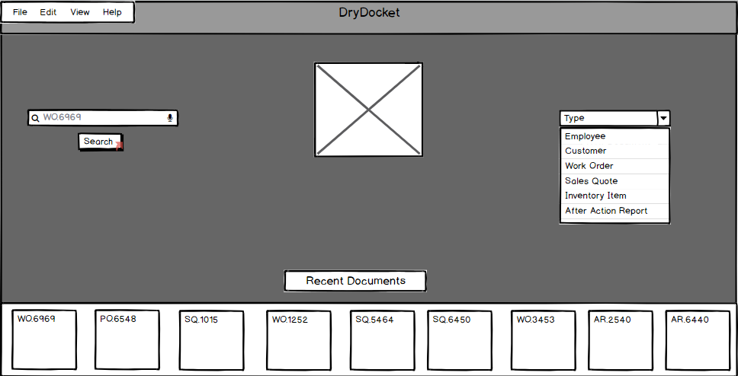

Figure XXX: Example Sales Quote

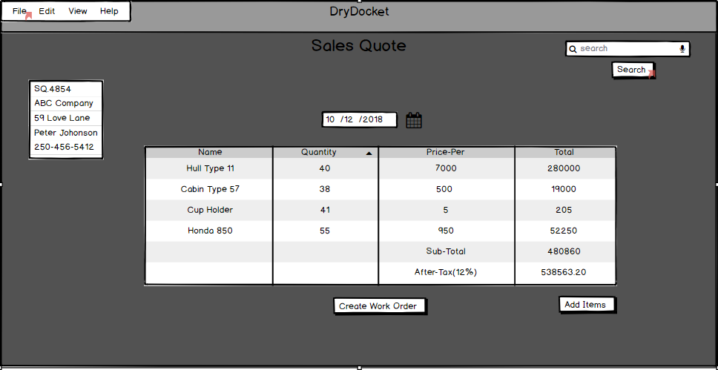

Figure XXX Sequence Diagram View Quote

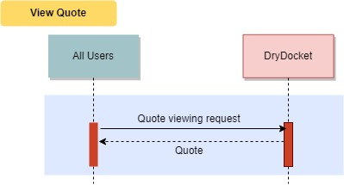

###### View Work Order

Summary: View a work order

Actors: All

Pre-conditions:

* User has logged in

Post-conditions:

* None

Basic Flow:

* The actor searches for a work order
* The actor examines the work order

Figure XXXX Searching for a Work Order



Figure XXXX Example Work Order

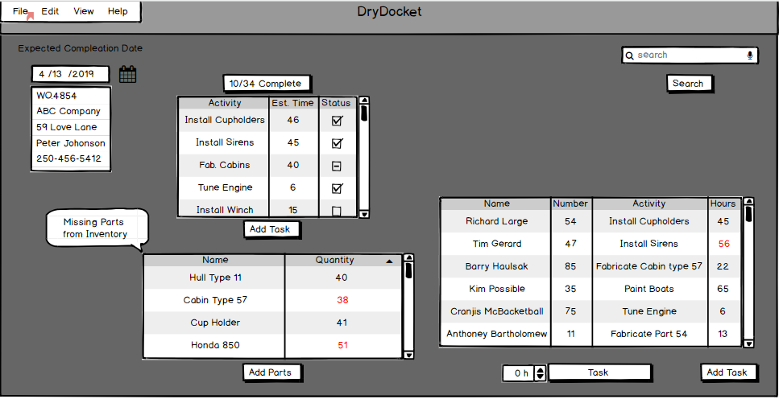

Figure XXX Sequence Diagram View Work Order

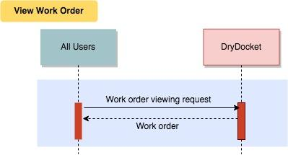

###### **View After Action Report**

Summary: View After Action Report

Actors: Accounting

Pre-Conditions:

* The user has logged in

Basic Flow

* An Accounting team member searches for an After Action Report
* The Accountant views the After Action Report

Figure XXX Searching for a After Action Report

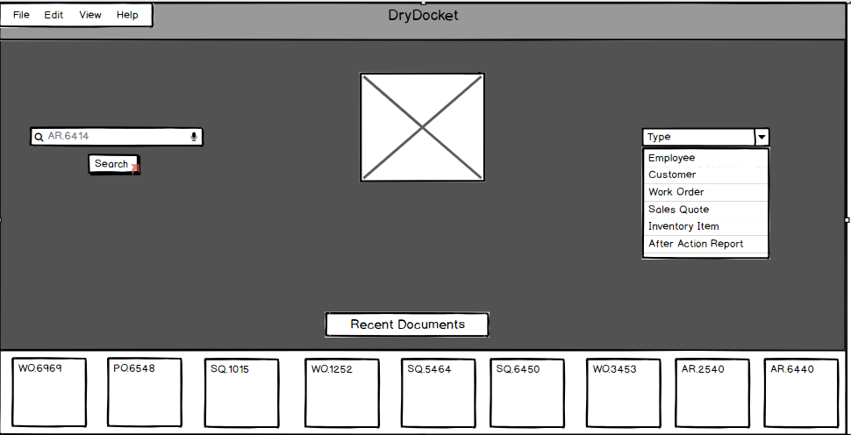

Figure XXX Example After Action Report:

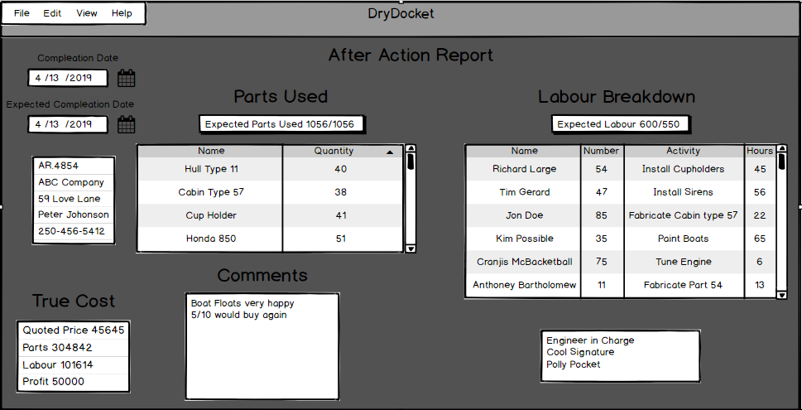

Figure XXX: Sequence Diagram View After Action

### 

###### Build Step

Summary: Mark a step of a work order as complete

Actors: Engineers

Pre-conditions:

* Work order step must need to be completed
* The user has logged in

Post-conditions:

* Work order step is marked as complete
* The calendar has a work log event created for the relating build and the Engineer

Basic Flow:

* Engineer may optionally mark the start of work logging for the build step.
* The *<<Include "Use inventory" >>* is used as needed throughout the build
* After the build, the build step is marked as completed in work order form
* Hours worked by the Engineer are logged in work order form.

Figure XXX: Work Order with Recently Added Parts

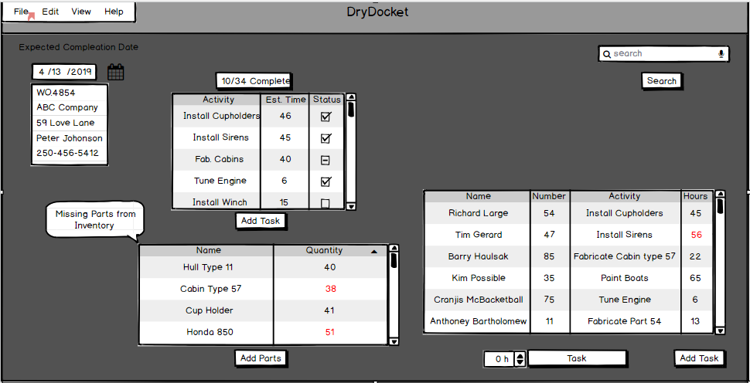

Figure XXX: Sequence Diagram Build Step

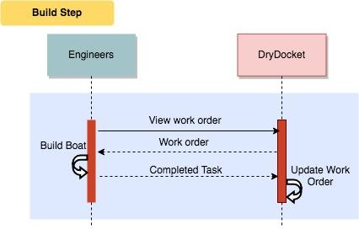

##### **3.1.2.2-STORAGE**

Files must be stored in an organized fashion that:

* Allows for easy access through a file DryDocket; and
* Can be discovered through a search query.

##### **3.1.2.3-BACKUP**

A backup storage DryDocket must be in place to allow access to previous versions of documents, as well as restore DryDocket in the event the main storage system encounters errors.

This backup system MUST be compatible with SpeedyBoats current backup suite.

Figure XXX Backup Interface

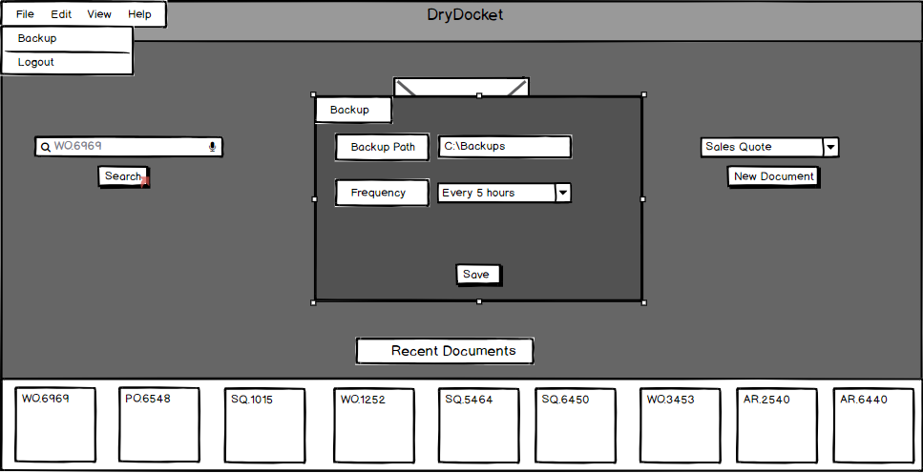

##### **3.1.2.4-DOCUMENT-CREATION**

DryDocket supports the creation and editing of Sales Quotes, Work Order, After Action Reports, and Inventory Items.

###### Create Quote

Summary: Allows sales to give clients a projected cost for the manufacturing of a boat

Actors: Sale

Pre-Condition:

* There is a request for a boat to be built
* The user is logged in

Post-Condition:

* Clients will decide if they accept the cost of their boat build
* A sales quote is added to DryDocket

Basic Flow:

* Request for boat build arrives from clients with product specifications
* Merchandise is added to the quote to match specifications
* Estimated prices are sent to clients
* Clients decide to accept or negotiate cost and specifications their wanted product
* Price is finalized, on to the next step of production.

Figure XXX: Example Quote

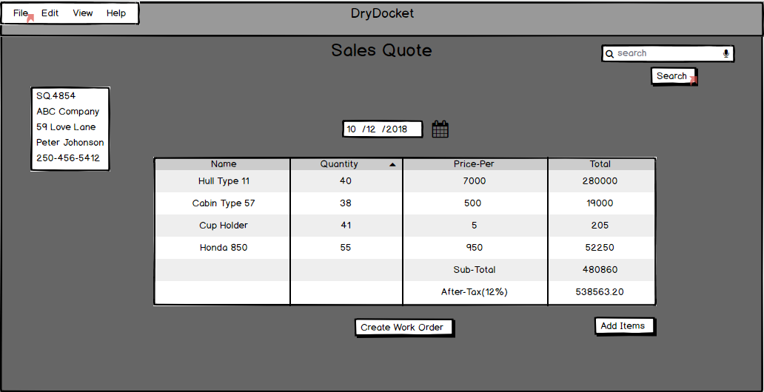

Figure XXX: Sequence Diagram for Create Quote

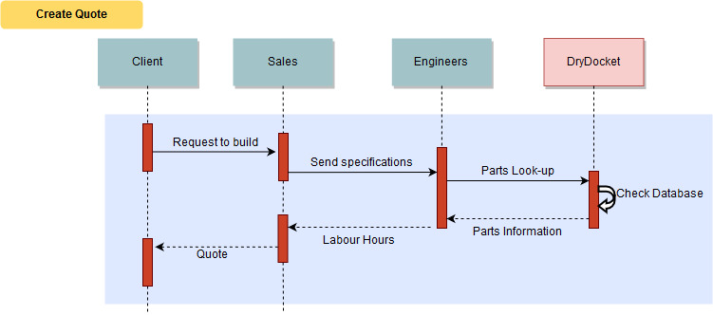

###### Create Work Order

Summary: Allows Engineers to Create Work Orders

Actors: Engineers

Pre-conditions:

* SpeedyBoats is ready to start manufacturing a boat
* The user has logged in
* A sales quote has been created and agreed on by the customer

Post-conditions:

* A work order is created
* The inventory will be modified
* The customer profile is updated

Basic Flow:

*Note: All actions are performed by the Engineer*

* A work order document is created from a sales quote
* The customer's profile is updated to show the new work order
* DryDocket changes inventory to reflect the parts used on this project
* The amount of hours needed by workers to assemble the boat is estimated and added to the work order
* A completion date for the work order is estimated and added
* The work order is finalized, saved, and submitted

Figure XXX. How to generate a work order

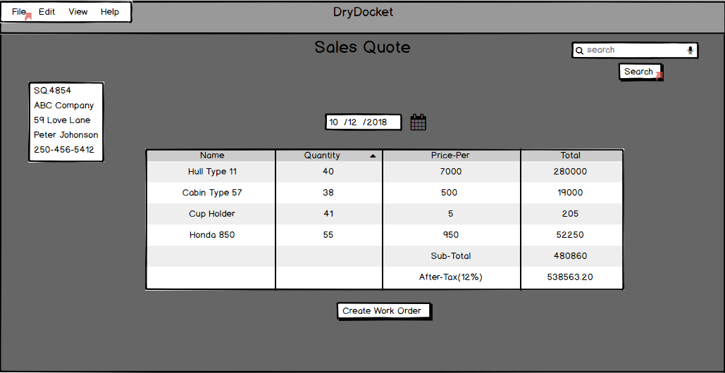

Figure XXX : Create an Empty Work Order

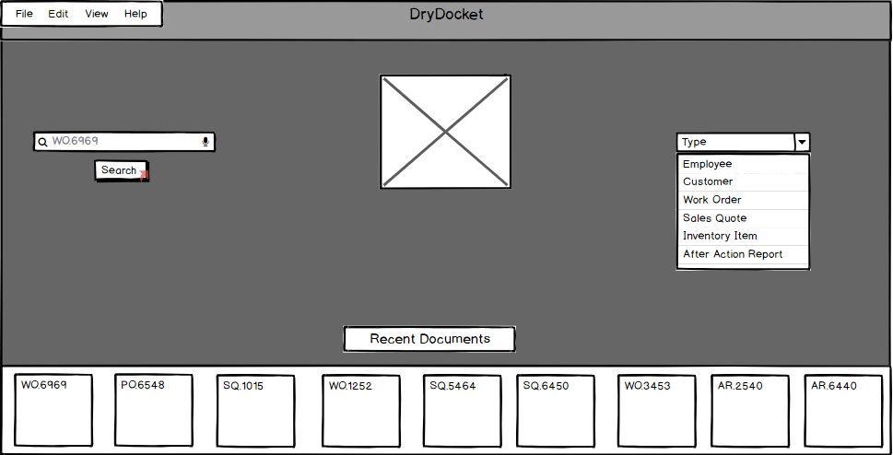

Figure XXX: Sequence Diagram Create work order

### 

###### Create After Action Report

Summary: An After Action report is created

Actors: Engineers

Pre-Conditions:

* The user is logged in
* All tasks of a work order have been completed
* The Merchandise has been delivered

Post-Conditions:

* An After Action report is added to DryDocket

Basic Flow:

* The Engineer searches for the completed work order
* The Engineer verified and signed off that the work order is correct and complete
* The Engineer selects the option to compute an after action report
* DryDocket calculates profit,customer,changes in labour estimates and parts used
* DryDocket formats this data and enters it into the after action report
* DryDocket adds the Engineers signature to the after action report
* DryDocket saves and submits the after action report

Figure XXX Example Generated After Action Report



Figure XXX: Create Empty After Action Report



Figure XXX Sequence Diagram Create After Action Report

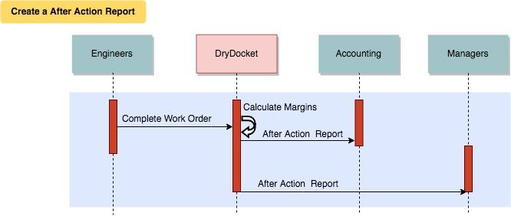

###### Edit Form Fields

Summary: Update the available fields for data entry forms

Actors: All

Pre-conditions:

* Must have an existing data entry form to modify

Post-conditions:

* All *future* documents that require data entry using that form will display the new fields. Existing documents are not updated.

Basic Flow:

* Direct:
* The actor is shown a list of existing forms in the ERM system to select
* The form is selected to be edited
* Fields can be renamed, re-ordered, deleted, or created. There must be no duplicate fields for the form to be saved
* The form is saved
* Indirect
* The form editing mode described above can be engaged while entering data in an existing form. The fields will be modified but the values will persist unless the field is deleted
* A confirmation dialog alerts the actor that their edits to the form fields, should they choose to save, will impact all future forms
* The form is saved, and the actor returns to data entry

Figure XXXX Example of Customizable Form

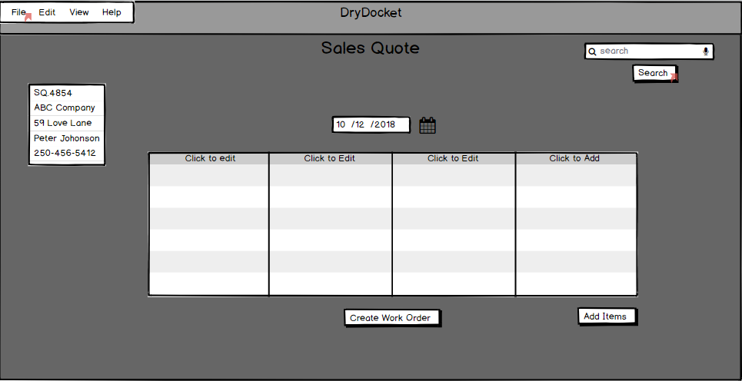

Figure XXX: Sequence diagram for Edit Form Fields:

### 

### **3.2 Automated Document Generation**

#### **3.2.1 Description and Priority**

The software will need to automate document creation process, and autofill duplicate contents without relying on additional user input.This functionality will be given *high* priority.

#### **3.2.2 Functional Requirements**

##### **1- AUTOFILL**

Software MUST be able to autofill duplicate contents:

* Work orders can be partially generated from a sales quote so parts list no longer have to be manually entered.
* After Action reports can be fully generated from work orders

Figure XXXX Generated Work Order



Figure XXXXX Generated After Action Report

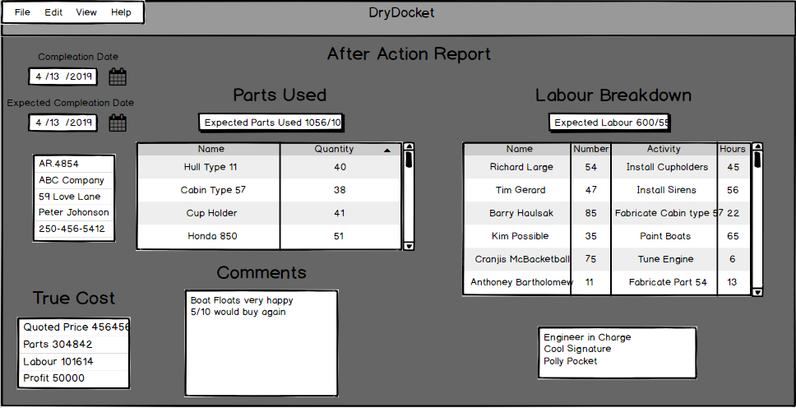

### **3.3 Log-In/Out**

#### **3.3.1 Description and Priority**

Users of the software will need to log in and out of their respective accounts. A secure system that monitors work-time must be used to enter and exit the software. This functionality will be given high priority.

#### **3.3.2 Functional Requirements**

##### **1-LOGIN**

Users MUST be able to log in and out of their accounts:

* Through a secure process that MUST NOT compromise the privacy of their account and login information; and
* So that they can access the features designated for their user class.

###### Login

Summary: Users must log into their accounts to access or interact with any portion of the software.

Actors: Everyone

Pre-condition:

* The user has a valid account in DryDocket

Post-Condition:

* Will be able to access and interact with DryDocket

Basic Flow:

* The users enters a employee number and password
* DryDocket verifies the credentials
* The credentials are valid access is granted

Figure XXXX Launch Screen of DryDocket

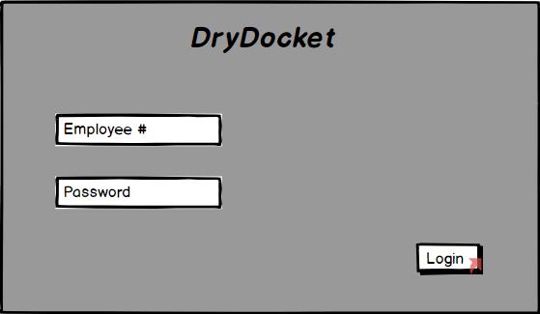

Figure XXXXX Successful Login

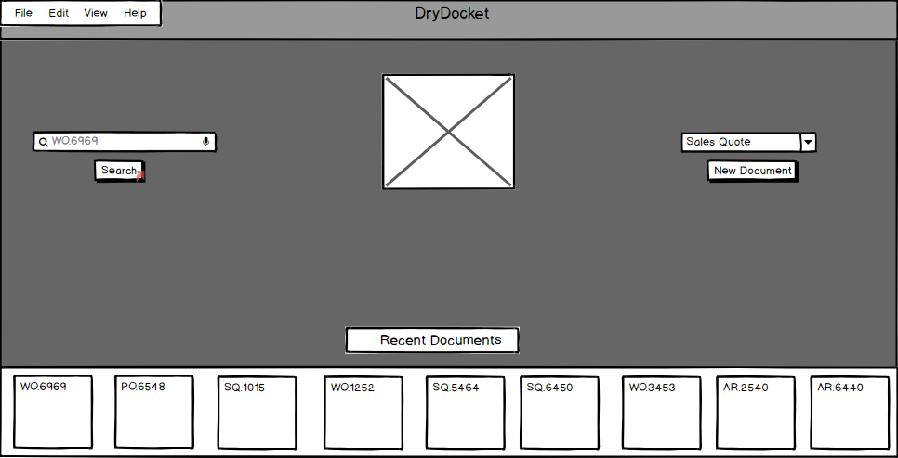

Figure XXXX Unsucessful login

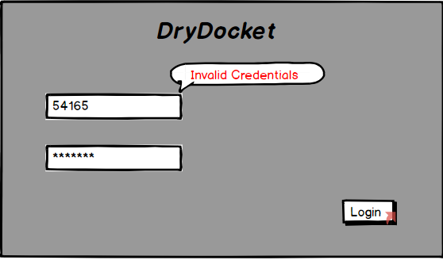

Figure XXX: Sequence diagram of Login

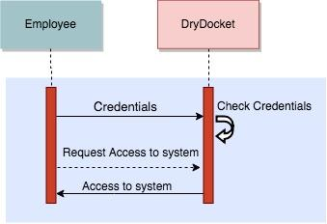

### **3.4 Profile Management**

#### **3.4.1 Description and Priority**

Managers MUST be able to edit and manage profiles of employees and customers. Furthermore, different access and operating permissions must be able to be set on each user.

#### **3.4.2 Functional Requirements**

##### **1- MANAGE PROFILES**

Managers MUST be able to act as a high level administrator and be able to manage profiles including:

* Create new profile
* Edit existing profile
* Remove profile

##### **2- CUSTOM MEMBERSHIP PERMISSIONS (EMPLOYEES ONLY)**

Managers MUST be able to assign custom memberships and set different access permissions for members including:

* Financial information access and modify permission
* Purchase information access and modify permission
* Material costs access and modify permission
* Engineering profiles (Frame instructure, drawings etc.) access and modify permission
* Manufacturers information access and modify permission

###### Update Customer Profile

Summary: Entry of customer information

Actors: Sales

Pre-conditions:

* The user has logged in

Post-conditions:

* Information on the Customer profile is changed

Basic Flow:

* The Customer profile is searched
* Changes are made to the Customer information
* The information is saved and submitted

Figure XXXX Customer Profile

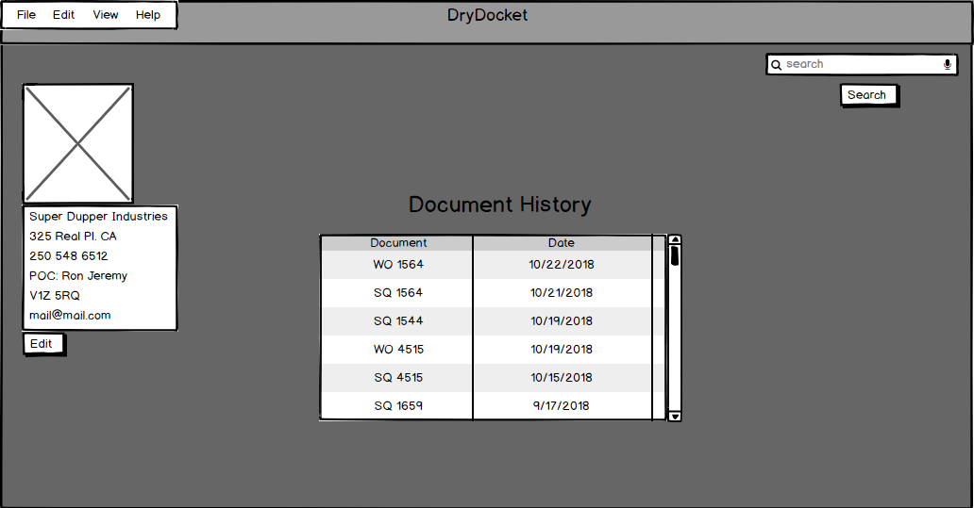

###### Add Customer Profiles

Summary: Allows the sales to create customers’ profiles.

Actors: Sales

Pre-conditions:

* The customer doesn’t exist in DryDocket.

Post-Condition:

* The customer’s profiles will be added.

Basic Flow:

This use case starts when a new customer comes in and enables the salesperson to create an account by entering information that’s needed in the customer’s profile.

* The salesperson input the customer’s name, address, postal code, email address, and phone number to DryDocket.

Figure XXXX Document Creation Screen

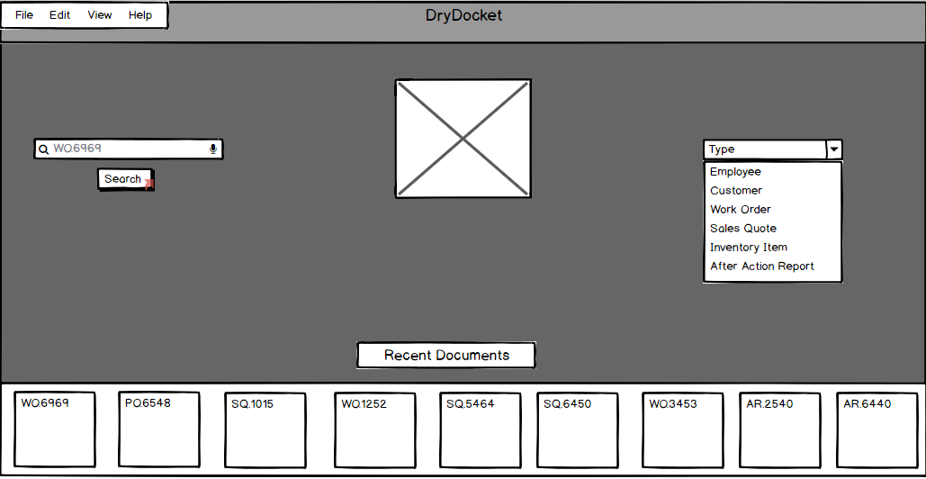

Figure XXX: Sequence diagram for Update Customer Profile

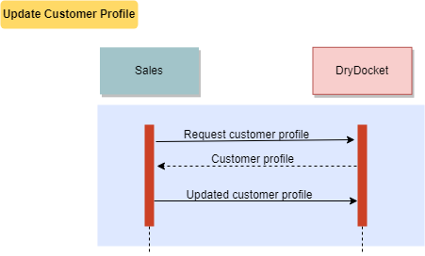

###### Add Employee Profiles

Summary: Allows the manager to create employees’ profiles.

Actors: Manager

Pre-conditions:

* The employee doesn’t exist in DryDocket

Post-Condition:

* The employee’s profiles will be added

Basic Flows:

This use case starts when a new employee starts registration process and enables the manager to create an account by entering information that’s needed in the employee’s profile.

* The manager input the employee’s name, address, postal code, email address, phone number, and SIN number to DryDocket.
* DryDocket notifies that the employee profile has been created.

Figure XXX: Document Creation Screen



Figure XXX: Sequence diagram for Add Employee Profiles

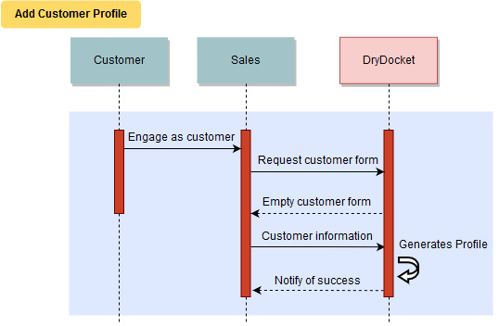

###### Edit Employee Profiles

Summary: Allows the manager to update the employee’s profile.

Actors: Managers

Pre-conditions:

* The employee exists in DryDocket.

Post-Condition:

* The employee’s profiles will be modified.

Basic Flows:

This use case starts when the manager access the employee’s profile and try to update his/her information that’s maintained in the the DryDocket.

* The DryDocket displays fields for the employee form (see *Edit Form Fields* use case) examples include the employee’s name, address, email address, phone number, and SIN number.
* The manager enters the desired employee profile information values and requests that the DryDocket saves the entered values.
* The DryDocket validates the entered employee profile information.
* The values for the employee profile that are stored in the DryDocket.
* The DryDocket notifies that the employee profile has been updated.

Figure XXX: Example Employee Profile

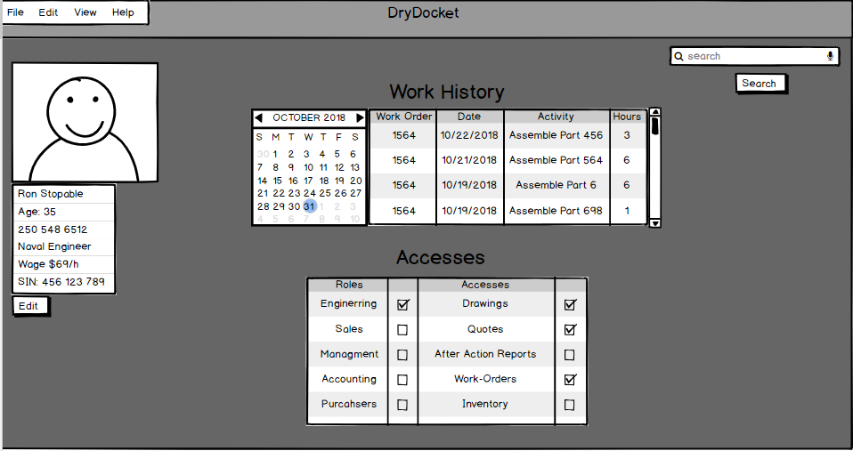

Figure XXX: Sequence diagram for Edit Employee Profiles

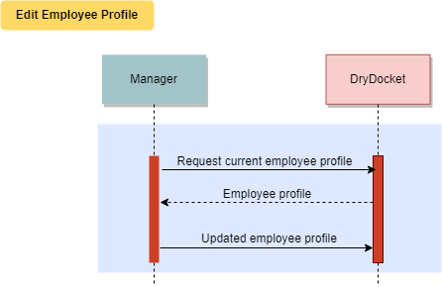

### **3.5 Files Upload**

#### **3.5.1 Description and Priority**

Users of this software will need to be able to upload files to DryDocket.

#### **3.5.2 Functional Requirements**

* Engineers are able to upload and link documents to inventory items
* Purchasers are able to upload files pertaining to inventory items

###### Upload Engineering Documents

Summary: Allows the engineering dept to upload specifications documents for the current boat they are producing

Actors: Engineers

Pre-Condition:

* Document is made and ready for upload (not created with our software)
* The user is logged in

Post-Condition:

* Document will be in the engineering document database

Basic Flow:

* Engineer completes their document
* The Engineer access the part’s inventory page
* The Engineer Edits the document list

Figure XXX Engineeringing Document interface

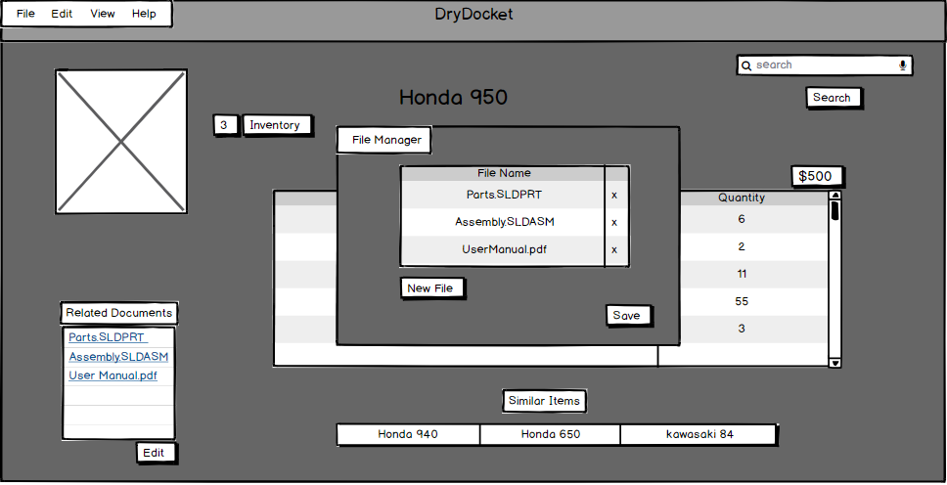

Figure XXX: Sequence diagram for Upload Engineering Documents

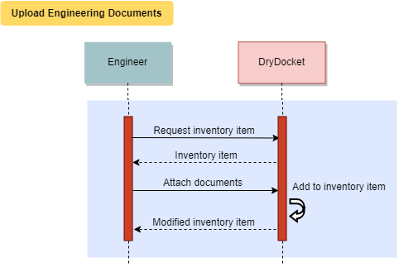

### **3.6 Inventory**

###### Resupply Inventory

Summary: Contact Purchasers to resupply missing inventory

Actors: Engineers, Purchasers

Pre-conditions:

* Inventory item is either out of stock or too low of stock for a required work order
* The user has logged in.

Post-conditions:

* Item is now in stock
* Engineer is updated that the item is now in stock

Basic Flow:

* Engineer creates a Parts request and forwards it to a Purchaser
* Purchaser contacts Supplier
* Purchaser orders and receives stock
* Purchaser notifies Engineer of new stock

Figure XXXX: Purchaser View of Inventory

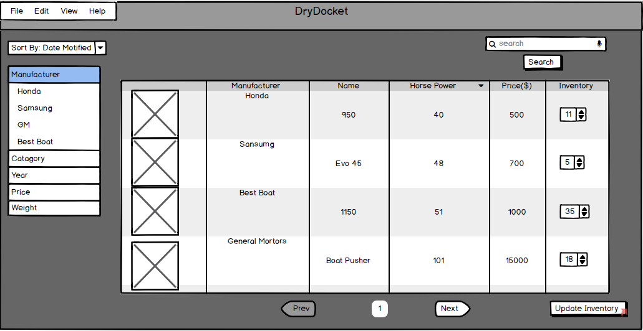

Figure XXXX: Sequence Diagram Resupply Inventory

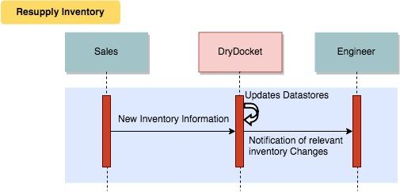

###### Check Inventory

Summary: See if an inventory item is in stock

Actors: Engineers, Purchaser

Pre-conditions:

* The user has logged in

Post-conditions:

* None

Basic Flow:

* The user searches for the part
* The user checks the inventory count

Figure XXXXX Example of Default Search View

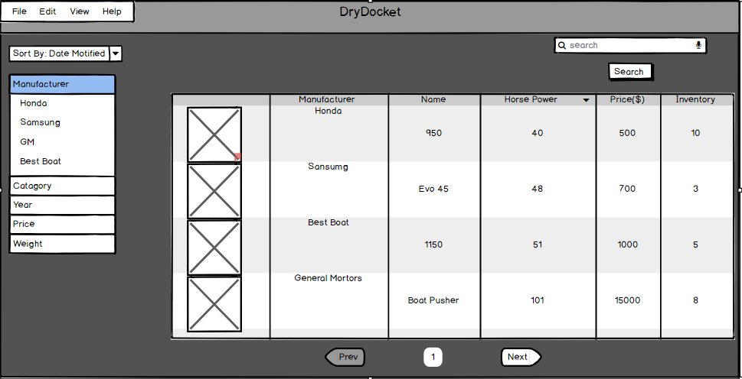

Figure XXXX Example of Detailed Part View

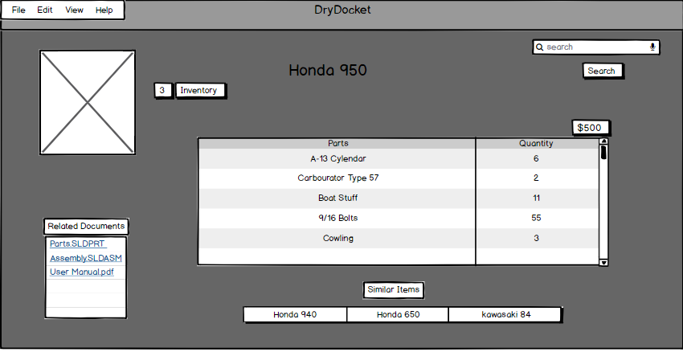

Figure XXX: Check Inventory Sequence Diagram

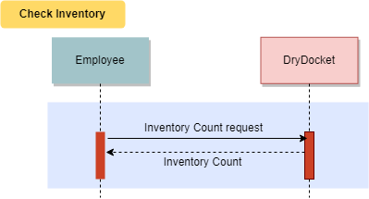

###### Use Inventory Item

Summary: Retrieves an item from inventory and marks it as used in a build

Actors*:* Engineers

Pre-conditions:

* Item must exist in inventory <<Include "Check Inventory">>
* The user has logged in
* A work order exists

Post-conditions:

* The work order is updated to show new part counts
* The inventory count is modified to have the new count

Basic Flow:

* An Engineer adds the part to a work order
* The inventory count is updated to show a part has been used

Figure XXX Example of Recently Added parts to a work order

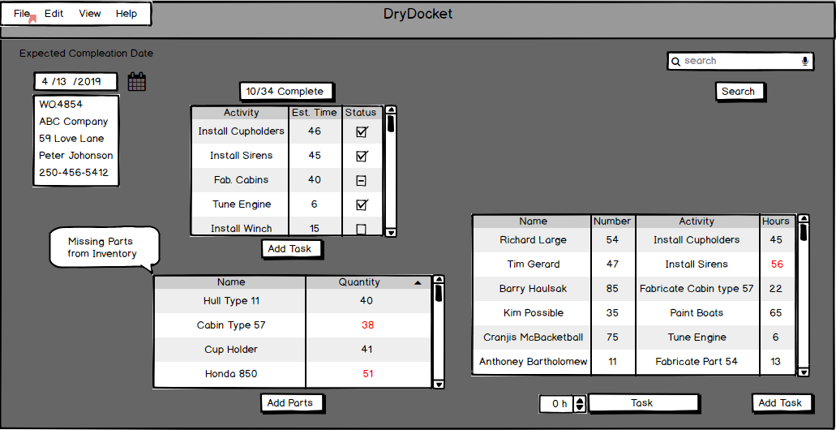

Figure XXX Sequence Diagram Use Inventory Item

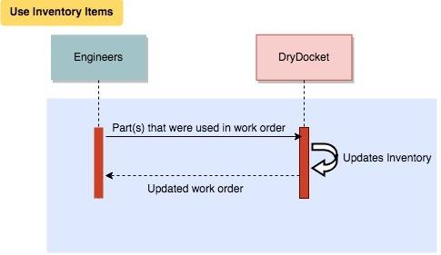

## **4 External Interface Requirements**

### **4.1 User Interfaces**

#### **4.1.1 Interface Accessibility**

**ID: EI1**

TITLE: Interface Accessibility

DESC: Employees must be able to find menu items with minimal effort

RAT: By designing the interface to be intuitive employee workflow increases

DEP: A usable interface

#### **4.1.2 Interface Dropdown Menus**

**ID:EI2**

TITLE: Interface Dropdown Menus

DESC: Dropdown menus will reduce the amount of manually entered data

RAT: By using dropdown menus and reducing typing employee workflow will increase

DEP: Dropdown menus exist on the interface to be used

#### **4.1.3 Previous Order Template**

**ID: EI3**

TITLE: Previous Order Template

DESC: Employees have the option to start a work order from an existing template

RAT: By allowing employees to start a work order from an existing template it will drastically increase workflow

DEP: An existing template of a previous order

### **4.2 Hardware Interfaces**

DryDocket does not interface with any hardware on the user end

### **4.3 Software Interfaces**

#### **4.3.1 Backup Data Export**

**ID: SI1**

TITLE: Backup Data Export

DESC: DryDocket will be able to export its data into a form compatible with SpeedyBoats current offsite backup system.

RAT: By allowing backup’s to be compatible with Speedyboats current system they will not have to replace their backup system

DEP: SpeedyBoats current backup system exists and the data format is the same as DryDocket

### **4.4 Communications Interfaces**

#### **4.4.1 Email Communication**

**ID: CI1**

TITLE: Email Communication

DESC: DryDocket is able to export data to email in an intuitive way

RAT: By easily allowing data to be exported to email it will increase the ease at which employees are able to exchange information over email.

DEP: None

## **5 Other Non Functional Requirements**

### **5.1 Performance Requirements**

#### **5.1.1 Concurrent Connections**

**ID: NFR1**

TITLE: Concurrent Connections

DESC: DryDocket must support up to 50 concurrent connections with no performance decrease

RAT: In order to allow multiple employees to use DryDocket without noticing slowdown

DEP: No dependencies required

#### **5.1.2 Form Access Time**

**ID: NFR2**

TITLE: Form Access Time

DESC: The time it takes to access to access a form from the database should be less than 5 seconds

RAT: The speed at which a form must be kept under one second to reduce workflow slow down and increase the efficiency at obtaining required database information

DEP: An existing form in the database

#### **5.1.3 Database Search Query**

**ID: NFR3**

TITLE: Database Search Query

DESC: The time it takes to search the database and receive a result should be less than 10 seconds

RAT: The speed at which a database returns a search query should return a result in less than 10 seconds in order to increase workflow efficiency.

DEP: A database must exist to be able to be queried

#### **5.1.4 Employee Profile Creation Usability**

**ID: NFR4**

TITLE: Employee Profile Creating Usability

DESC: Adding a new complete employee profile should take 1 hour between creation and completion

RAT: New employees being added to DryDocket should have a fully functional employee profile within 1 hour of beginning to add the employee to a fully complete employee profile

DEP: A database containing employee profiles

#### **5.1.5 Employee Permission Changes**

**ID: NFR5**

TITLE: Employee Permission Changes

DESC: Permission changes on an employee profile should take effect within 1 minute of being assigned

RAT: Employees permission changes need to take effect within one minute to allow them access to previously non permissible information and increase workflow.

DEP: An existing employee profile

#### **5.1.6 Form Autofill**

**ID: NFR6**

TITLE: Form Autofill

DESC: When inputting text on a document the autofill should instantaneously suggest options to select

RAT: By instantaneously suggesting autofill options this will reduce the time needed to employees to type out tedious information

DEP: A form currently being worked on

### **5.2 Safety Requirements**

#### **5.2.1 Previous Interface Backup System**

**ID: NFR7**

TITLE: Previous Interface Backup System

DESC: DryDocket will interface with the previous backup system of E2, to be able to recover previous backups

RAT: By interfacing with the previous backup system E2, data will be able to be recovered and used by DryDocket.

DEP: The existence of backups used on the prior E2 system.

#### **5.2.2 Off-Site Backup**

**ID: NFR8**

TITLE: Off-Site Backup

DESC: DryDocket will backup to an off-site server every 5 hours

RAT: By backing up off site, DryDocket will be able to store and recover information in the case of a failure

DEP: An off site server that accepts backups

#### **5.2.4 Unique Backup File**

**ID: NFR9**

TITLE: Unique Backup File

DESC: DryDocket will store each backup as a unique file

RAT: By storing each backup as a unique file, DryDocket will be able to recover from numerous different points.

DEP: A off-site server that accepts backups

### **5.3 Security Requirements**

#### **5.3.1 Part Diagram Access Permissions**

**ID: NFR10**

TITLE: Part Diagram Access Permissions

DESC: DryDocket will only allow users with the Engineer role to access part diagrams

RAT: By allowing only Engineers to access part diagrams it satisfies permission requests as laid out by SpeedyBoats.

DEP: A part diagram with access permissions assigned

#### **5.3.2 Gaining Access to DryDocket**

**ID:NFR11**

TITLE: Gaining Access to DryDocket

DESC: How DryDocket users will authenticate themselves

RAT: By ensuring all users of DryDocket are authenticated with a password and employee number it will satisfy the security requirement as described by SpeedyBoats

DEP: An active version of DryDocket

#### **5.3.4 Captured Data Confidentiality**

**ID: NFR12**

TITLE: Captured Data Confidentiality

DESC: DryDocket will encrypt all stored data with AES-256

RAT: By encrypting all stored data this reduce breaches of confidential information

DEP: Existing files within DryDockets

#### **5.3.5 File Deletion**

**ID: NFR13**

TITLE: File Deletion

DESC: DryDocket will only allow users with Engineer or Management permissions the ability to delete files

RAT: By only allowing users with Engineers or Management permissions the ability to delete files the security of the files satisfies SpeedyBoats permission requests

DEP: Existing files within DryDockets, users with Engineer or Management permissions

#### **5.3.6 Role Management**

**ID: NFR14**

TITLE: Role Management

DESC: DryDocket will only allow Managers to change the view and edit permissions of employees

RAT: By only allowing users with Management permissions the ability to change permissions the security of the files satisfies SpeedyBoats permission requests

DEP: Active employees within DryDocket and at least one with a manager role

#### **5.3.7 True Cost Analysis**

**ID: NFR15**

TITLE: True Cost Analysis

DESC: DryDocket will only allow purchasers,accountants and Managers to see the true cost of inventory

RAT: This information is highly confidential to SpeedyBoats and was a requirement from SpeedyBoats that this information be restricted

DEP: Existing files within DryDockets

### **5.4 Software Quality Attributes**

#### **5.4.1 Application Portability**

**ID: SQ1**

TITLE: Application Portability

DESC: DryDocket must be able to run on all internet browsers with version of 2015 or later

RAT: DryDocket needs to be compatible with all browsers to allow compatibility with any operating system

DEP: Web Browser with a version of 2015 or later

#### **5.4.2 Availability During Updates**

**ID: SQ2**

TITLE: Availability During Upgrades

DESC: DryDocket will not be available during upgrades for a period of UP TO 12 hours

RAT: DryDocket will have transition downtimes of UP TO 12 hours during upgrades. This will allow DryDocket to begin upgrades at the end of a work day (8pm) and be available again by the morning (8am)

DEP: None

#### **5.4.3 DryDocket Failover**

**ID: SQ3**

TITLE: DryDocket Failover

DESC: DryDocket if for any reason fails will be back online within 1 hour

RAT: By having a 1 hour or less turnaround time of a complete system reboot from a backup DryDocket aims to reduce workflow disruptions

DEP: An existing backup of DryDocket to reboot from

## **6 Additional Requirements**

New users must be able to obtain basic proficiency with less than 4 hours of training. Basic proficiency means that the users knows how to complete all the tasks that arise from common use of the software but may need assistance in more advanced tasks.

The database is able to migrate to a new environment while remaining operational. It can take a long time to fully transfer a database to a new location, it would be unacceptable if the data was unavailable during this process.

## **7 Analysis Models**

All use cases below assume the user and their device have valid authentication for DryDocket. If the device is not yet authenticated, DryDocket redirects them to a login page where they provide their credentials before continuing. Credentials are erased on logout.

### **7.1 Use Case Model**

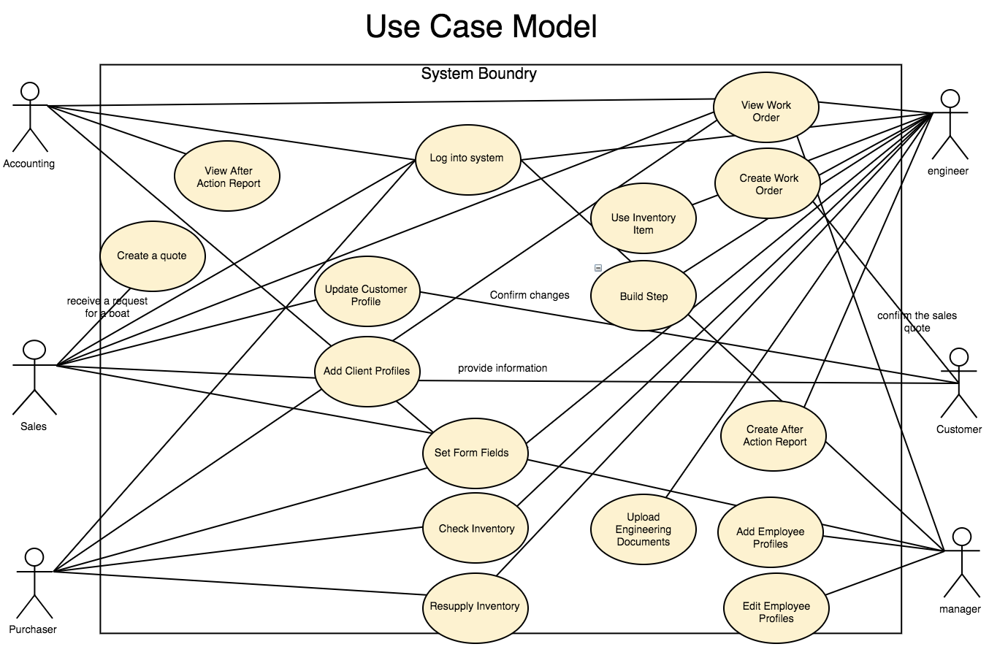

Use case model describes the proposed functionality of DryDocket system. Each bubble represent a single use case, and each use case represents the interaction between our potential users and the DryDocket system. (Use cases are specified in Section 3: DryDocket Features)

### **7.2 Entity Relationship Diagram**

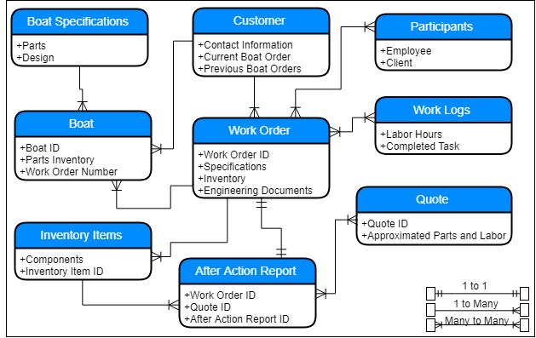

Entity relationship diagram describes the proposed relationships that each entity will be connected to with the DryDocket system. Each bubble has the name of the entity with the attributes that pertain to that entity.

### **7.3 Data Flow Diagrams**

#### **7.3.1 [DFD 0]**

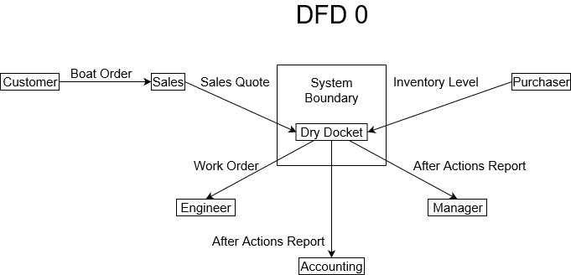

DFD 0 illustrates what each user, on a high level, provides or receives from DryDocket. After receiving an order from a Customer, Salespersons provide Sales Quotes, Purchasers stock Inventory, Engineers receive Work Orders, and Accountants and Managers receive After Action Reports.

#### **7.3.2 [DFD 1]**

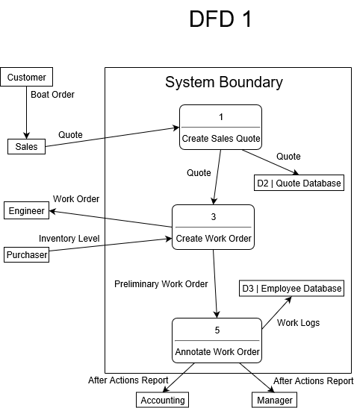

DFD 1 expands on the main process in the DryDocket software. Salespersons create sales quotes, which causes the system to create a Work Order for Engineers to use. Purchasers monitor inventory as necessary, and then the system completes the work orders to log employee hours and provide after actions reports for Accounting and Management.

#### **7.3.2 [DFD 2]**

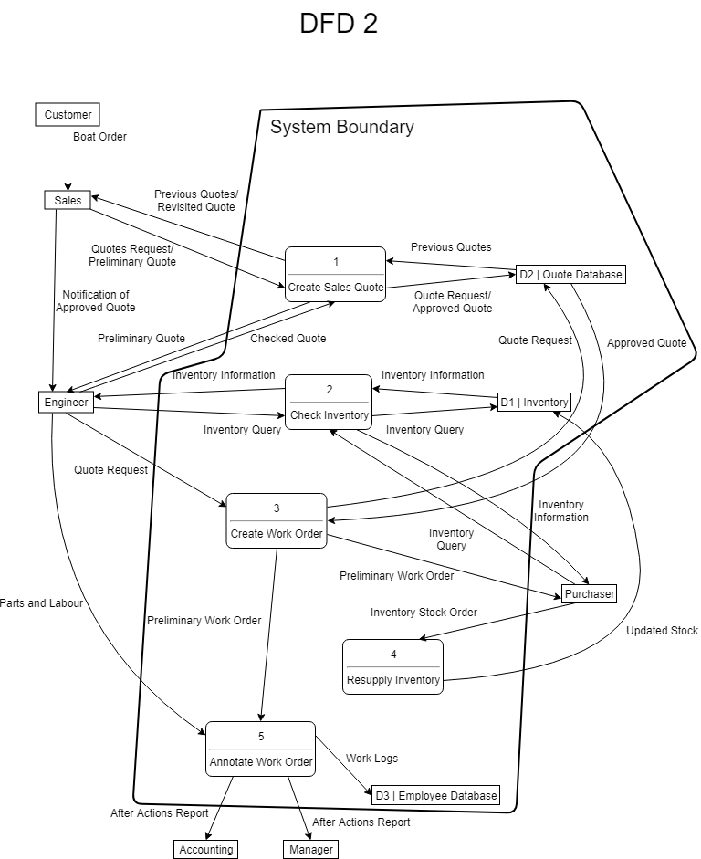

DFD 2 expands on the complex data flow in each previous step of the main software process. Salespersons use previous quotes as a reference, and send a preliminary quote to engineers via the software. Engineers can view pricing of inventory parts to help them decide whether to approve the Salespersons’ quotes, or send them back to Salespersons for review. This process repeats until Engineers approve of the quote, in which case it will be finalized by Salespersons and stored in the Quote Database.

Once the quote is finalized, Salespersons will notify the Engineers (via means outside of the system such as email). Engineers will then review the finalized quote and create a Preliminary Work Order via the software. The Preliminary Work Order is sent to the Purchaser to resupply on inventory as necessary, and then annotated by the software.

After annotating the work order, the system stores employee Work Logs for salary management and provides Accounting and Management with an After Actions Report.

## **Appendix: Issues List**

A scheduling system was discussed with Speedyboats but negotiations are still underway as to whether this is a desired feature.